1. Data Engineering - 20%
2. Exploratory Data Analysis - 24%
3. Modeling - 36%
4. ML Implementations and Operations - 20%

**1. Data Engineering**

**1.1. S3**

* S3 allows people to store objects (files) in buckets (directories).
* Buckets must have a globally unique name.
* Objects have keys (file path): buckets/objects. Max size: 5TB. Support any data format.
* Object Tags: key/value pairs. Useful for security.

**1.1.2. S3 Data Partitioning**

* Useful for range queries.
* Service eg: Kinesis.

**1.1.3. S3 Storage Classes**

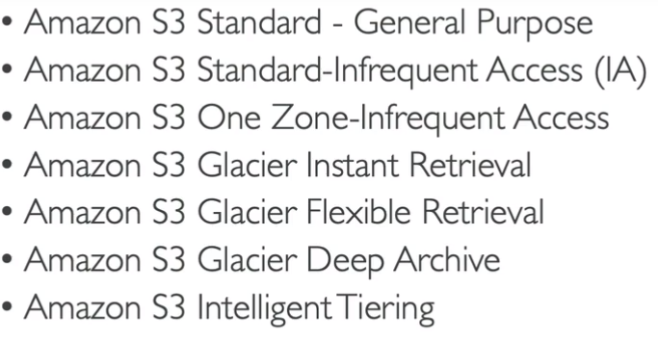

**1.1.4. S3 Durability and Availability**

* Durability: How many times object is going to be lost by Amazon S3. Durability is 99.99999999999% across all S3 services.
* Availability: How readily available service is. Different S3 classes have different availability.

**1.1.5. S3 Standard**

* Frequently accessed data. Availability 99.99%, low latency, high throughput.
* Use cases: Big data analytics, mobile & gaming applications, content distribution.

**1.1.6. S3 Infrequent Access**

* Less frequently accessed data, when required rapidly accessed. Lower cost than S3 standard. 99.9% availability.
* Use cases: Disaster recovery, Backups.

**1.1.7. S3 One Zone - IA**

* Availability 99.5%. 1 Availability Zone.
* Use cases: Bring secondary copies of on-premises data, recreating data.

**1.1.8. S3 Glacier**

* Low cost. Archiving/Backup. Price for storage + Object retrieval cost.
* Amazon S3 Glacier Instant retrieval - Retrieval in milliseconds.Min Storage duration 90 Days.
* Amazon S3 Glacier Flexible retrieval - Retrieval in Expedited (1-5 mins), Standard (3-5 hrs), Bulk (5-12 hrs) - Free. Min Storage duration 90 Days.
* Amazon S3 Glacier Deep archive - Retrieval in Standard (12 hrs), Bulk (48 hrs). Long-term Storage duration min 180 Days.

**1.1.9. S3 Automatic Tiering**

Cost for only monthly monitoring and auto-tiering access tiers.

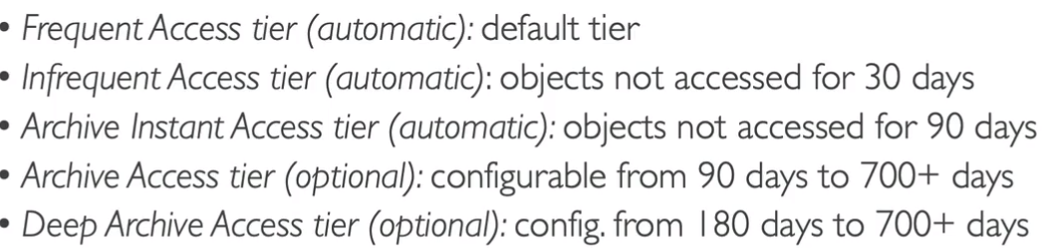

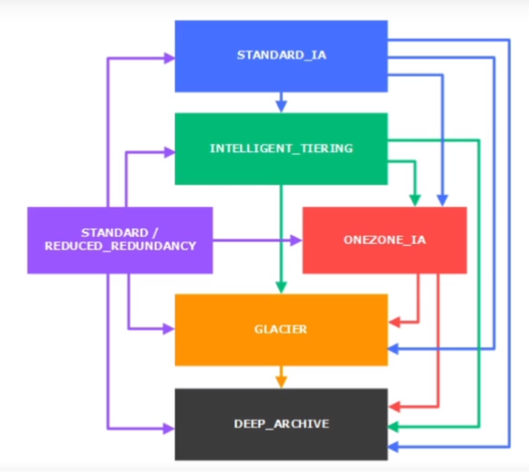

**1.1.10. S3 Lifecycle rules**

* Automatic rules to be applied to objects in a bucket.
* Transition actions - Move objects from 1 storage class to another, Expiration actions - Delete objects as per condition (in days, old versions, incomplete data upload), Rules as per prefixes such as mp3 directory objects, rules per object tags (eg: objects with tag Department: Finance).
* Minimum 30 days removal.

**1.1.11. S3 Encryption for Objects**

* SSE-S3 - using keys handled and managed by AWS.

SSE (Server Side Encryption)

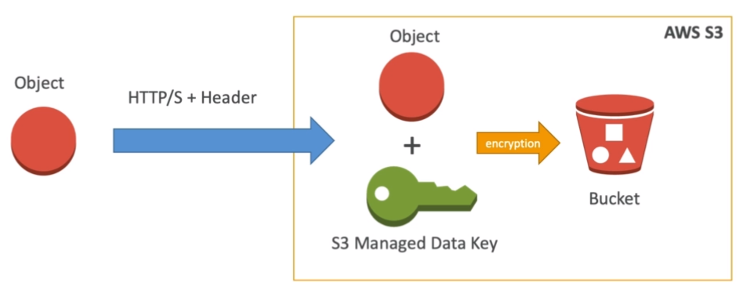

* SSE-KMS - Key Management Service to manage encryption keys. (Access control, audit trail).

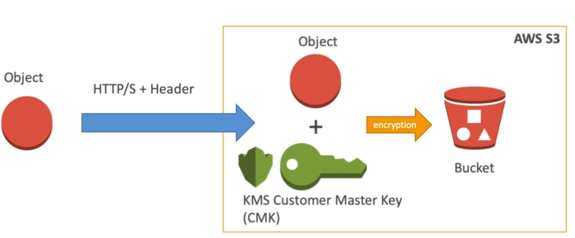

* SSE-C - Manage own encryption keys.
* Client-side encryption.

**1.1.12. S3 Security**

* User Based - IAM (Identity Access Management) which users have access to which API.
* Resource Based - Bucket Policy, Object Access Control List, Bucket Access Control List.
* S3 Default Encryption - Encrypt every object sent to the bucket.
* Networking - Avoid public access of traffic through VPC (Virtual Private Cloud) Endpoint gateway.
* Logging and auditing of access. (eg. CloudTrail)
* Tagged based + IAM policy + Bucket policy. (eg. Allow IAM user access to tag object classification = PHI)

**1.1.13. S3 Bucket Policies**

* JSON-based policies with key Resources - buckets/objects, Actions - set of APIs to allow/deny, Principal - account/user to apply the policy.
* Use cases: grand public access, force encryption of the object at upload, grant access to another account.

**1.2. Kinesis**

* Alternative to Apache Kafka, used for logs, metrics, IoT device information, clickstreams, real-time Big Data, and stream processing frameworks (Spark, NiFi, etc).
* Replication to 3 AZ automatically.

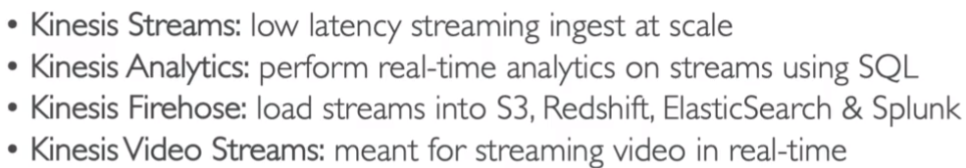with video analytics.

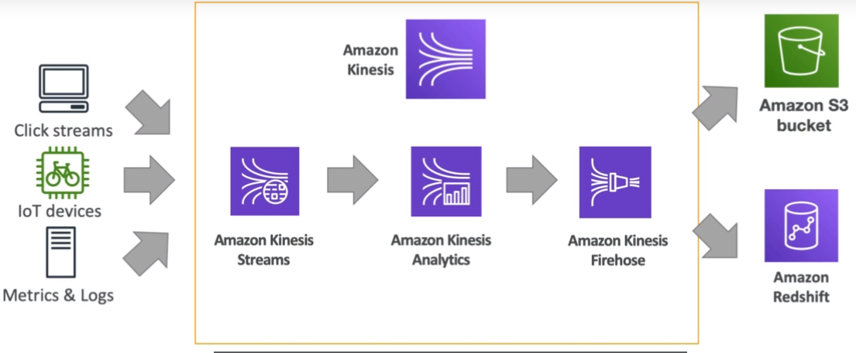

**1.2.1. Kinesis Streams**

Real-time Streams (200 ms classic, 70 ms enhanced latency) are divided into ordered shards or partitions. Custom code for consumer/producer supported.

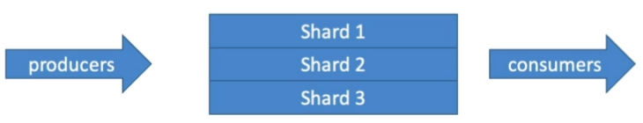

* Retention in 24 hrs default, up to 365 days with the ability to replay/reprocess the data, therefore multiple applications can consume the same stream at that time being.
* Data insertions are immutable (no deletion).
* Used for a small amount of data up to 1MB.
* Capacity Modes:
  + Provisioned - The number of shards to be provisioned is chosen, with manual or API-based scaling. Each shard gets 1MB/s or 1000 records/s IN throughput, and 2MB/s OUT throughput. Pay per shards provisioned/hr.
  + On-demand - No capacity management of shards. Default capacity provisioned (4MB/s). Automatic scaling based on observed throughput peak during 30 days. Pay/stream per hour & data in/out per GB.
* Limit: Producer - 1MB/s or 1000 msgs/s at write per shard, Consumer classic - 2 MB/s per at read per shard & 5 API calls/s per shard.

**1.2.2. Kinesis Data Firehose**

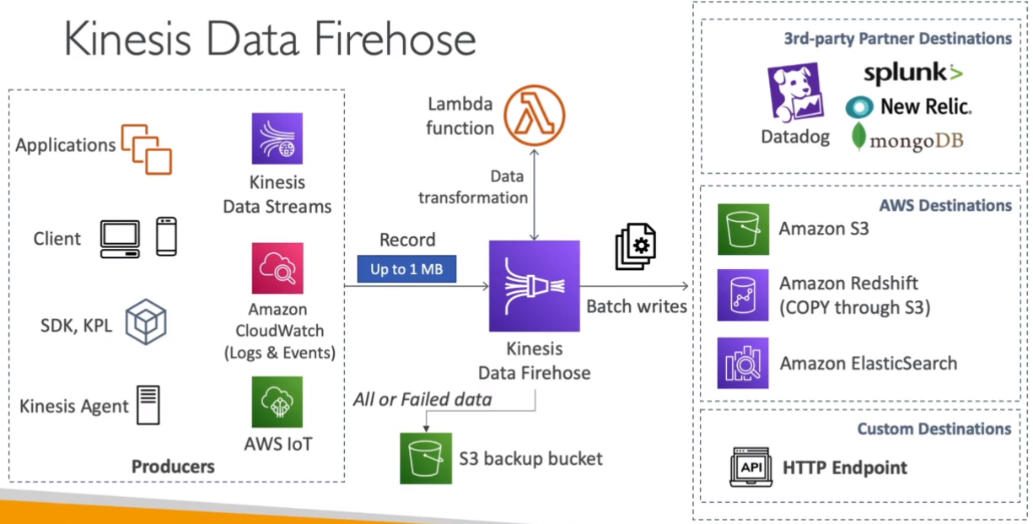

* Fully managed delivery/ingestion service for massive near real-time data streams (60 secs latency for a nonfull batch) with auto-scaling.
* Data ingestion into Redshift (data warehouse), Amazon S3, Elastic Search (index-based), Splunk (3rd party).
* Supports many data formats, data conversion to CSV/Parquet/JSON/ORC (only S3), transformation using AWS Lambda (eg: CSV=>JSON), and compression when the target is S3 (GZiP, ZiP, Snappy).
* No data storage for replay capability.
* Pay for the amount of data going through Firehose.

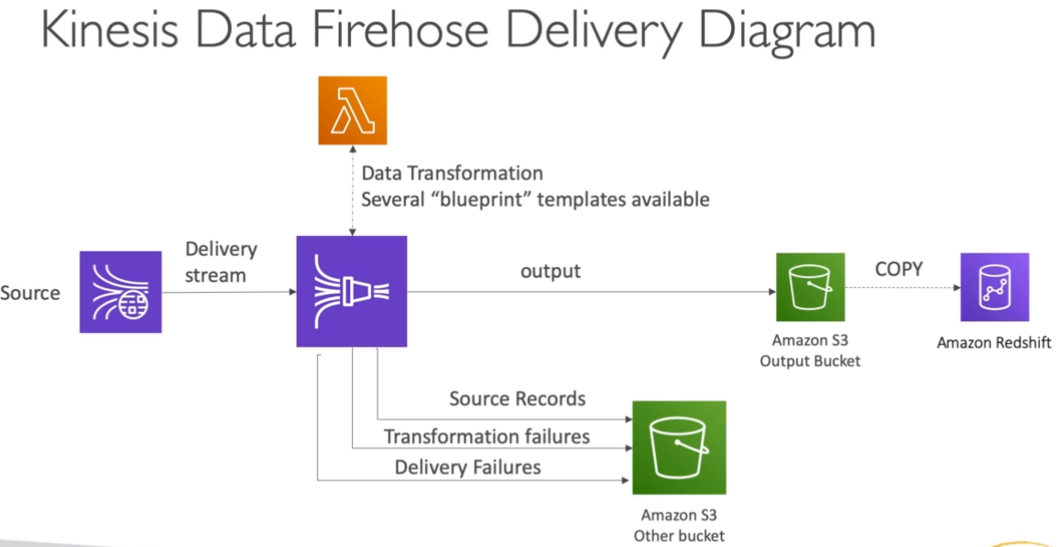

**1.2.3. Kinesis Analytics (Real-time analytics)**

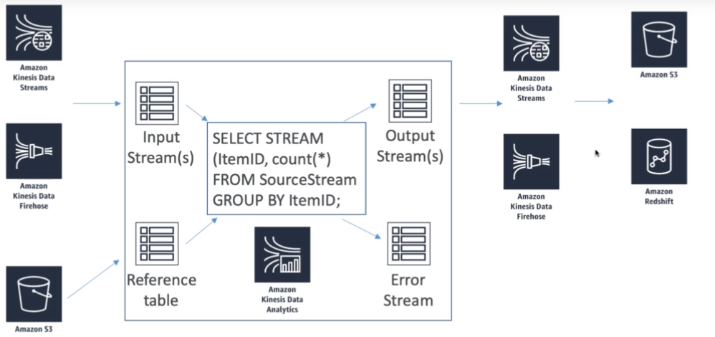

* Use cases: Streaming ETL (Extract, Transform, Load) - select columns, simple transformation on streams, Continuous metric generation - Live leaderboard of a mobile game, Responsive analytics - find the unusual patterns for certain criteria and build alerts for the same.
* Serverless service with auto-scale, pay only for resources consumed, using IAM permission for access control on the source(s) & destination(s), SQL(eg: for Kinesis firehose)/Flink for computations, Lambda for pre-processing, discover schema features.
* For machine learning, we can apply 2 models directly: Random Cut Forest (Everchanging model) - Used for anomaly detection based on recent history (Eg: detect anomalous subway ridership during NYC marathon), Hotspots - locate and return info about relatively dense regions in data (Eg: a collection of overheated servers in the data center).

**1.2.4. Kinesis Video Streams**

* Producers can be security cameras, body-worn cameras, AWS Deeplens, smartphone cameras, audio feeds, images, RADAR data, and RTSP cameras.
* Consumers can be custom (MXNet, Tensorflow), AWS Sagemaker, Amazon Rekognition video, etc.
* One producer per video stream.
* Video playback capability.
* Retention of 1 hr to 10 yrs.

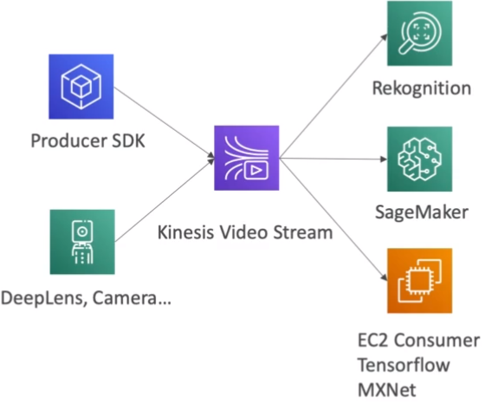

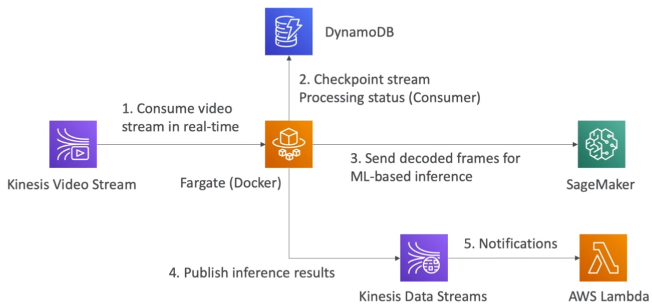

**1.3. Glue Data Catalog**

* Metadata repository for all the tables with automated schema inference and schema versioning.
* Can integrate with Athena and Redshift spectrum for schema and data discovery.
* Glue crawlers help in building Glue Data Catalog.

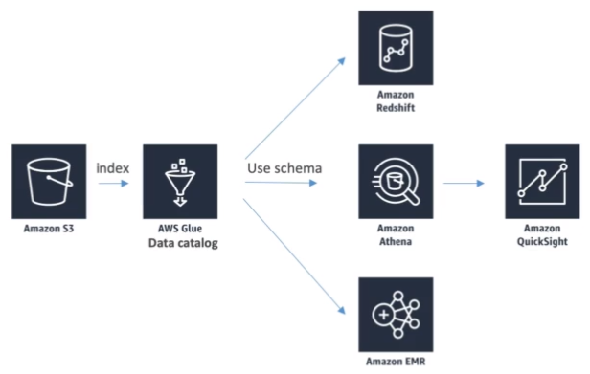

**1.3.1. Glue Crawlers**

* Crawlers go through the data to infer schemas and partitions(Eg: from S3 based on how your data is organized).

Example: Devices send sensor data hourly.

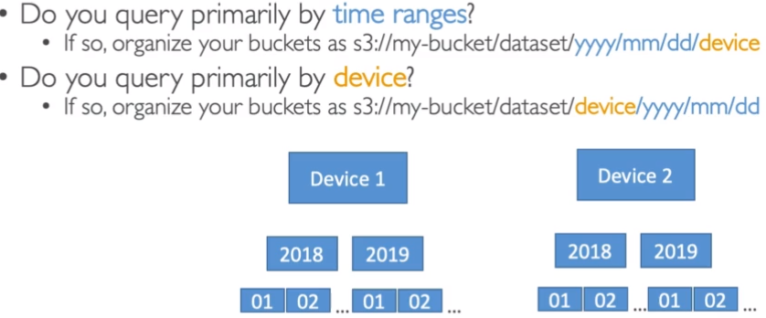

* They can work with different data formats such as CSV, JSON, Parquet, relational store, and different data sources such as S3, Amazon Redshift, and Amazon RDS.
* The crawler can run on schedule or On Demand.
* IAM Role access/credentials are required.

**1.3.2. Glue ETL (Extract, Transform, Load)**

* Fully managed, cost-effective, pay only for resources consumed service that allows transformation, cleaning, and enriching data.
* Can either generate ETL code in Scala/Python or provide your own Spark/PySpark scripts.
* Resources belong to AWS so we might not have easy access to some of the resources.
* Target can be S3, JDBC (RDS, Redshift), or Glue Data catalog.
* Can run spark jobs on serverless spark platform, Glue Scheduler can be used to schedule the jobs, and Glue Triggers to run jobs based on events.
* Transformation such as Bundled (drop fields/null fields, filter records using the function, join data, map to add/delete/lookup fields), ML (FindML matches for approximate records even if they do not have a common unique ID or are exactly same), format conversions (JSON, CSV, Parquet, ORC, Avro, XML), Spark (eg: KMeans algorithm).

**1.4. AWS ML Data stores**

* Redshift - Big Data database needed to be provisioned in advance.
  + Data warehouse technology with SQL analytics (OLAP - Online analytical processing) feature.
  + Used for running SQL queries on a massive amount of data in parallel, and doing some analytics on them.
  + By default, we have to load data from S3 to Redshift, but we can use the Redshift Spectrum to run SQL queries directly on S3.
  + Columnar-based - Data is organized in columns.
* RDS, Aurora -
  + Relation store with SQL, OLTP (Online Transactional Processing) feature.
  + Row-based - Data is organized in rows.
  + Used when we want to store data regarding the model for exports.
  + Provisioning servers in advance is a must.
* DynamoDB -
  + NoSQL (Not Only SQL) data store.
  + Provisioning read/write capacity is a must.
  + Serverless.
  + Useful to store machine learning models (eg. model output) served by applications.
* S3
* OpenSearch (ElasticSearch) -
  + Indexing of data.
  + Search amongst data points.
  + Clickstream analytics.
  + No machine learning direct integration.
* Elastic cache - Used for caching in case there is a frequent requirement of certain data.

**1.5. AWS Data pipeline**

* Data pipeline is an ETL service to move data from one place to another with the capability to do retries and send notifications for failures.
* Orchestrator that manages task dependencies. (ETL happens in EC2/EMR instances)
* Destinations can include S3, RDS, DynamoDB, Redshift, and EMR.
* Sources may be on-premises.
* High availability.
* Flexibility to manage the environment, resources required to run the code, and the code itself.
* Example -

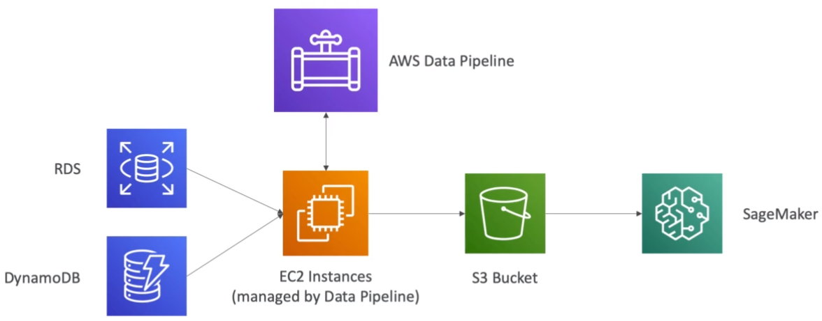

**1.6. AWS Batch**

* Serverless service (no need to manage clusters) that runs any computing and non-ETL related batch jobs as Docker images.
* Do not need to provision EC2 or Spot instances.
* Figures out the optimal quantity and type of instances based on volumes of jobs and requirements automatically.
* Pay for underlying instances created.
* Schedule batch jobs using Cloudwatch events, or orchestrate batch jobs using the Step function.

**1.7. AWS DMS (Database Migration Service)**

* Resilient and self-healing service that provides a quick and secured way of migrating databases to AWS.
* The Source database remains available during the migration.
* Supports homogeneous migrations (eg. Oracle to Oracle) and some heterogeneous migrations (eg. MSSQL Server to Aurora).
* Uses Continuous Data replication using CDC (Continuous Data capture), and EC2 instances must be created for replication tasks.
* No transformation.

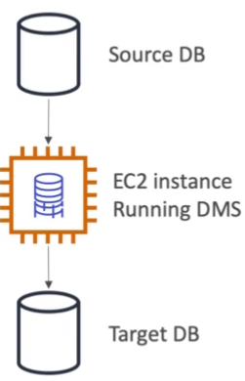

**1.8. AWS step Functions**

* Orchestrator using which we can make sure that the service workflows work well.
* Use to design workflows with easy visualizations, and advanced error handling and retry mechanisms outside the code.
* Has audit of history of workflows.
* Ability to ‘Wait’ an arbitrary amount of time.
* Max execution time of a state machine (workflow) is 1 year.

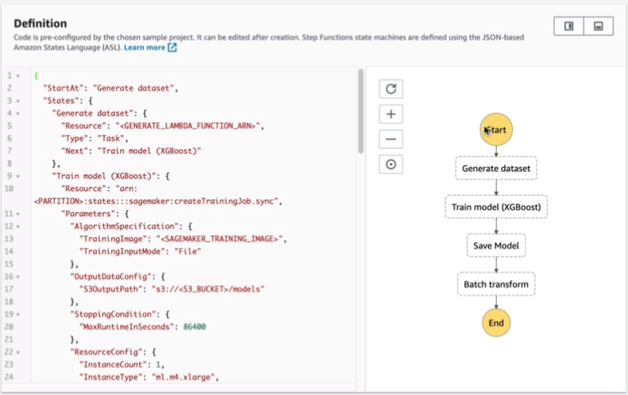

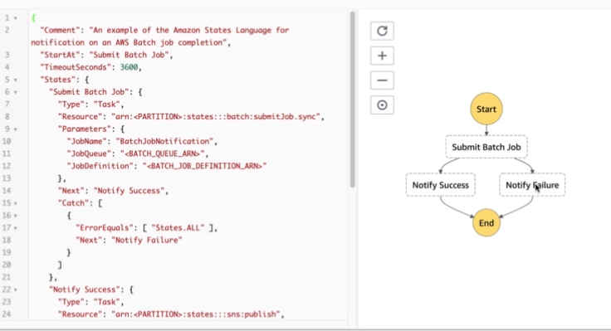

**1.9. Full Data-Engineering Pipeline**

* Real-Time Layer

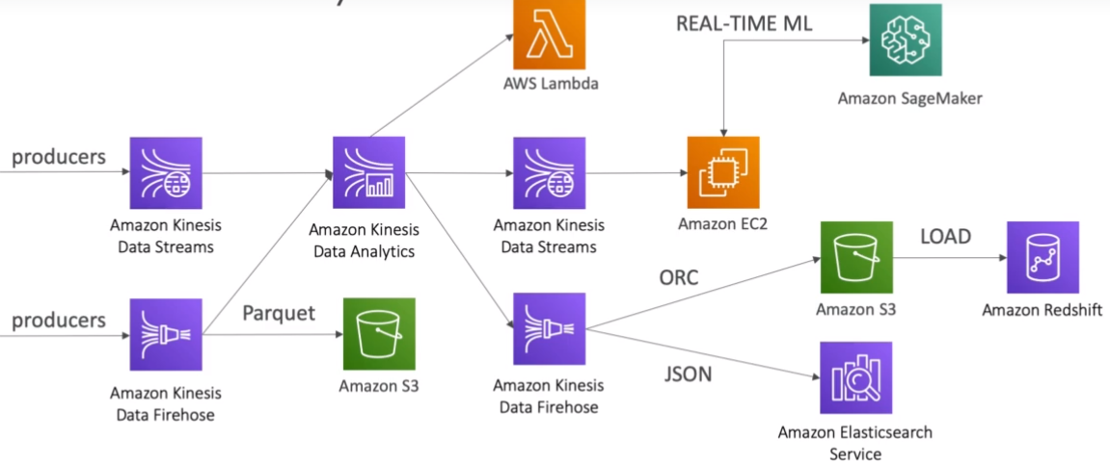

* Video Layer

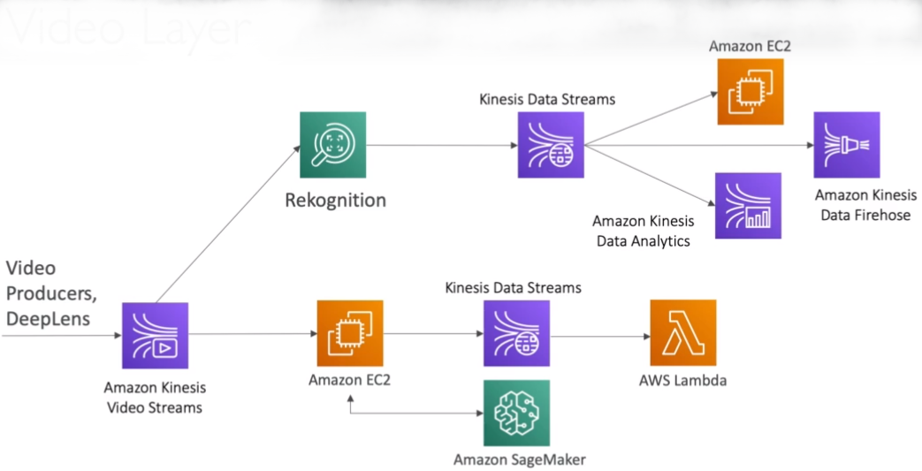

* Batch Layer

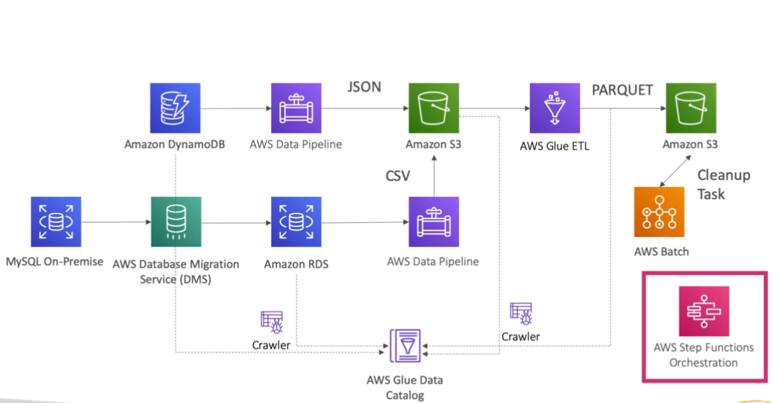

* Analytics Layer

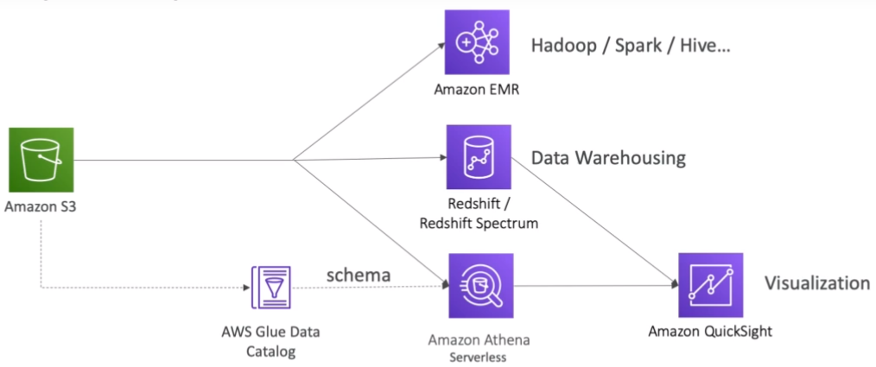

**1.10. Summary**

* Amazon S3: Object Storage for your data
* VPC Endpoint Gateway: Privately access your S3 bucket without going through the public internet
* Kinesis Data Streams: real-time data streams, need capacity planning, real-time applications
* Kinesis Data Firehose: near real-time data ingestion to S3, Redshift, ElasticSearch, Splunk
* Kinesis Data Analytics: SQL transformations on streaming data
* Kinesis Video Streams: real-time video feeds
* Glue Data Catalog & Crawlers: Metadata repositories for schemas and datasets in your account
* Glue ETL: ETL Jobs as Spark programs, run on a serverless Spark Cluster
* DynamoDB: NoSQL store
* Redshift: Data Warehousing for OLAP, SQL language
* Redshift Spectrum: Redshift on data in S3 (without the need to load it first in Redshift)
* RDS / Aurora: Relational Data Store for OLTP, SQL language
* ElasticSearch: index for your data, search capability, clickstream analytics
* ElastiCache: data cache technology
* Data Pipelines: Orchestration of ETL jobs between RDS, DynamoDB, and S3. Runs on EC2 instances
* Batch: batch jobs run as Docker containers - not just for data, manage EC2 instances for you
* DMS: Database Migration Service, 1-to-1 CDC replication, no ETL
* Step Functions: Orchestration of workflows, audit, retry mechanisms

**2. Exploratory Data Analytics**

**2.1. Libraries**

* Pandas - Data manipulation
* Series - a 1D array that can represent a single row.
* DataFrame - Similar to table
* NumPy (Numerical Python) - Numerical and algebraic processing of arrays. Often in some models, the data (eg. images) can be converted into a NumPy array (eg. pixel code) and then sent to the model.
* Matplotlib - Data visualization in python.
* Seaborn - Upgraded version of matplotlib built on top of matplotlib.
* Scikit_learn (sklearn) - Python library for machine learning models. (train, predict, preprocess (eg. scaling), split data into train and test, etc).
* TensorFlow/Keras (TensorFlow API) - Deep Learning python library.

**2.2.** **Types of Data**

* Numerical - Quantitative Data.
  + Discrete - Counts, Integers.
  + Continuous - Infinite range of values, Float.
* Categorical - Qualitative Data with no mathematical meaning.
  + Gender, Yes/No, Product, Category, etc.
* Ordinal - Mixture of categorical data and numerical data, where categorical data has some mathematical meaning.
  + Rating from 1-5 where 1 means the worst and 5 means the best.
* **2.3. Data Distributions**
* The likelihood of the data falling into a specific range.
* Normal Distribution -

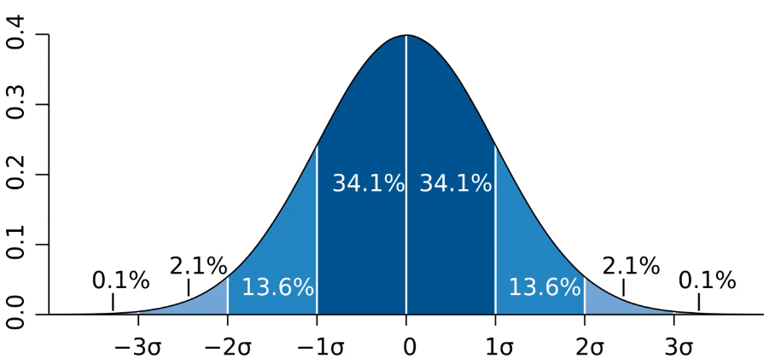

* Probability of a data falling into a specific range of values (pdf - probability density function for continues and pmf - probability mass function for discrete), where in normal distribution most of the data are in the range of 1st standard deviation (approx. 68%) giving a bell-shaped curve as a visualization of the data.

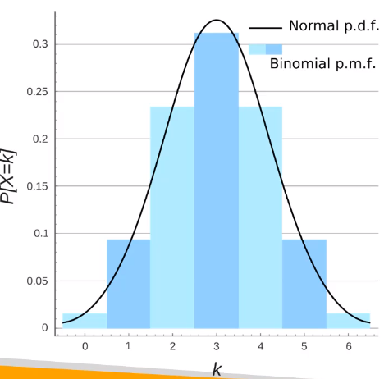

* Poisson Distribution - The number of times an event occurs on average is given, it gives us the likelihood of some number of events to occur within a time. (eg. likelihood of some number of houses bought in a day when the average likelihood is given)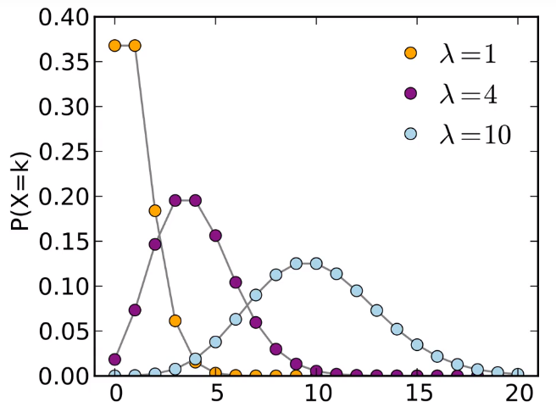

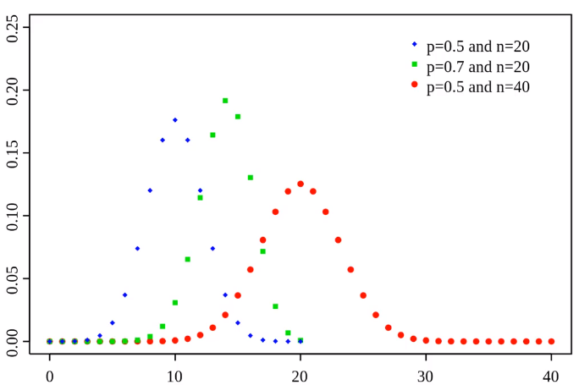

* Bernoulli Distribution - Single Trial Binary distribution. (eg. The patient is diagnosed with cancer or not)
* Binomial Distribution - Sum of bernoulli distributions. Multiple trials.

**2.4. Time Series Analysis**

* Time Series data is the data taken over a period of time.
* Time series analysis takes historical data in order to forecast future trends or patterns of the data.
* Trend - Long-run increase or decrease over time (data taken over a long time period).

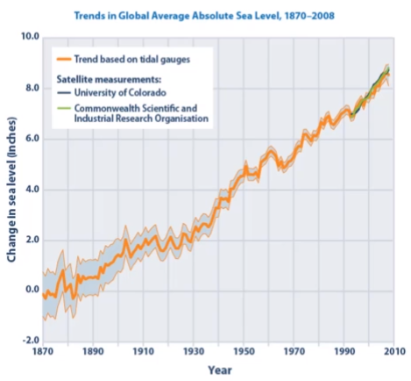

* Seasonality - The data has a short-term regular wave-like pattern. In other words, shows some season-based patterns over a short period of time (eg. monthly, quarterly).

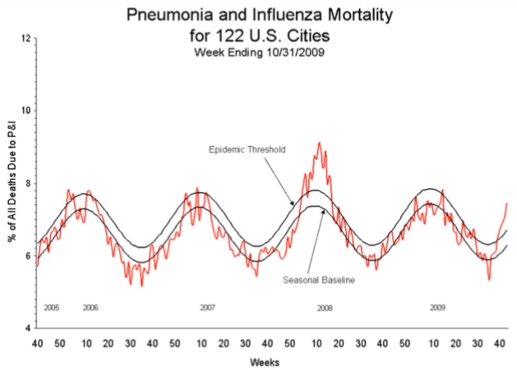

* Data can have both seasonality and trend. For eg, the Wikipedia data on visits may have seasonal patterns with a high peak in some months and a trend of visitors increasing over time.

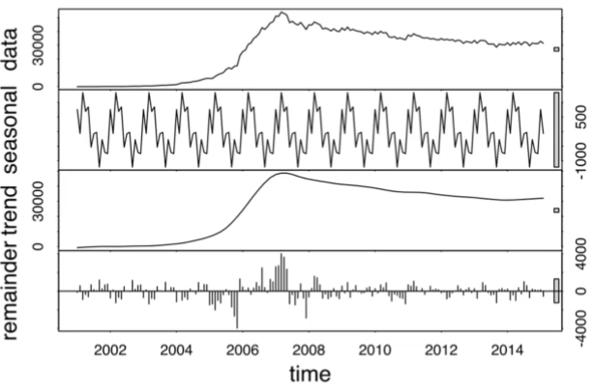

* Noise - Random variations pattern in data. In this case, we can model data in two ways:
  + Additive modeling if the seasonal variation is constant (seasonality + trend + noise = time series).
  + Multiplicative model if seasonality scales along with trend such that, as the scale of the data/trend variation increases or decreases the seasonal variation also increases or decreases (seasonality * trend * noise = time series).

**2.5. Amazon Athena**

* Serverless way of interacting S3 data lake using queries (SQL) powered by open-source Presto.
* Allows us to execute queries on any data format CSV, Parquet, JSON, ORC, etc, and any data type structured/semi-structured/unstructured without loading the data into the database.
* Use cases - Analyze weblogs using Adhoc queries, analyze staging data before loading to Redshift, Analyze CloudFront, VPC, etc logs stored in S3.
* Can integrate with Jupyter, RStudio, Zeppelin notebooks, Quicksight for BI analysis, and other visualization tools under JDBC/ODBC protocol.

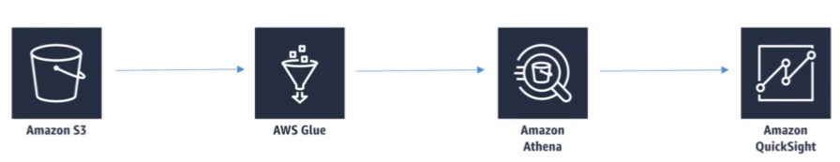

* Data from S3 can be crawled by Glue to figure out the schema and act as a metadata repository or for ETL purposes, Amazon Athena can then make use of Glue to figure out the column names and query on S3 data and at last, the result of the query can be visualized in Quicksight.
* Pay-as-you-go model with the cheap cost of 5$/TB of data scanned. Does not takes into consideration failed queries and DDL queries. Can be more cost-effective by compression or for columnar formats such as Parquet, ORC, etc.
* Security using IAM, bucket policies, encryption of query results/data in transit, etc.
* Not for visualizations and ETL.

**2.6. Amazon Quicksight**

* Fast, easy, serverless, business analytics service used for building visualizations (eg. dashboards/KPIs/stories), performing ad-hoc analysis, get business insights anytime and anywhere (eg. browser, mobile).
* For machine learning insights it has features such as Anomaly detection, Forecasting using Random cut forest, and Auto-narratives to summarise visuals in plain language.
* Allows limited ETL for some data preparations (eg. change field name).
* Allows different data sources such as Redshift, Athena, Aurora/RDS, database hosted on EC2 instances, TSV/CSV/log files, etc.
* Datasets can be imported into SPICE which is a super fast, parallel, highly-available, durable, in-memory calculation engine that uses columnar storage and in-memory machine code generation to accelerate queries that run on large datasets. It can scale up to 100s and 1000s of users where each user gets the capability of 10GB of SPICE.
* Security using multi-factor authentication, VPC connectivity (IP address range)/access (Elastic Network Interface, AWS Direct Connect), and row-level security.
* User management using IAM, email, and Active Directory.

**2.6.1. Quicksight Visual Types**

Autograph - Selects graph automatically based on the properties of the data.

Bar charts - Comparison and distributions (histograms).

Line graphs - Changes over time.

Scatter plot, Heatmap - Correlation between features or attributes.

Pie graphs, Treemaps - Aggregation of data.

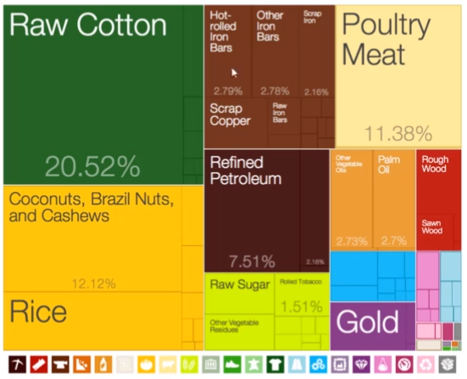

Pivot table - Showing tabular data in different ways (eg. grouping).

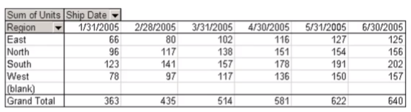

Story - Narratives for visualization that are used to convey key points, thought process, the evolution of analysis, etc.

**2.7. Elastic Map Reduce (EMR)**

* Managed Hadoop framework that runs on EC2 instances.
* Includes technologies like HBase, Spark, Hive, Flink, Presto, etc.
* EMR Notebooks feature similar to jupyter notebook allows running code on EMR clusters.
* Has several AWS integration points for eg. EC2 instances as nodes of a cluster, VPC to launch the virtual network, S3 for storage of input/output data, CloudWatch to monitor cluster performance and configure alerts, IAM to configure permissions, CloudTrail for auditing requests to service, Data pipeline for scheduling and starting clusters, etc.
* Used in case of processing, preparing, scaling, or normalizing massive data before sending into ML algorithm using distributed cluster architecture (processing load distributed across a cluster of computers).
* EMR cluster - Collection of EC2 instances where each EC2 instance is called a node. Node types:
  + Master node - Manages the cluster by running software components to coordinate the distribution of data and tasks among other nodes, tracks the status of the tasks, and monitors the health of the cluster.
  + Core node - Use software components that run tasks and store data into HDFS (Hadoop Distributed File System) which stores data in a distributed manner as blocks (default size of the block is 128 MB and replication is 3). Scalable with some risks, and fault tolerant.
  + Task node - Only runs tasks. Good use of spot instances because we can introduce or remove them out of cluster as per need.

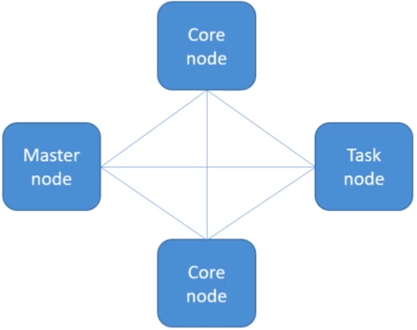

* EMR cluster can be used as a transient cluster which is automatically terminated when it completes all the defined steps of the task (eg. using spot instances), or for repeatable tasks we go for long-running clusters (eg. using reserved instances to save cost) which are terminated manually.
* Frameworks and applications to be installed are selected at the time of the launch of the cluster.
* Direct connect using master node through EC2 and run jobs from the terminal, or submit ordered steps via console.
* Storage can be default HDFS, EMRFS that is S3 with similar effect/access of HDFS with S3 consistency (optional) and DynamoDB to track that consistency, local file system, or EBS (Elastic Block Storage) for HDFS.
* EMR charges per hr + EC2 charges.

**2.7.1. Hadoop**

Hadoop consists of modules such as:

* HDFS for storing files in a distributed manner with replication on different instance nodes along with scaling and caching intermediate results of Mapreduce properties.
* Yarn (Yet another resource negotiator which manages) for central management of cluster resources for multiple data processing frameworks (eg. MapReduce).
* MapReduce framework to write software applications easily that processes a massive amount of data in parallel on large clusters of commodity hardware in a reliable, fault-tolerant manner. It consists of 2 functions:
  + Mapper - To map data or iterate through data perform some transformations, reformatting, or just simple extraction and create key-value pairs as intermediate results.
  + Reducer - Combines/groups/aggregates intermediate results, applies additional algorithms, and provides final output.

**2.7.2. Apache Spark**

* Spark is a faster alternative to MapReduce that utilizes in-memory caching, and optimized fast query execution using Directed Acyclic Graph (DAG) that makes it smart about dependencies, processing, and effective scheduling.
* Open-source distributed processing systems commonly used for Big Data workloads.
* APIs for Scala, Python, and R with code reuse capability across multiple workloads (eg. interactive queries in real-time analytics and ML, etc).
* Spark applications run as an independent set of processes on clusters.
* Allows integration with Zepplin to run code interactively in notebook environment, execute SQL queries against SparkSQL, preprocess data, and visualize query results.
* Working of Spark:
  + Driver program - Used SparkContextObject of the main program that coordinates processes. Actual Code to run Spark job.
  + Cluster Manager (YARN, Spark) - The driver program connects to different cluster managers to allocate resources across the applications.
  + Executors - After connection, executors that are processes are acquired on nodes in the cluster that run computations and stored data for the applications i.e. application code. In the end, it runs tasks send by SparkContext.

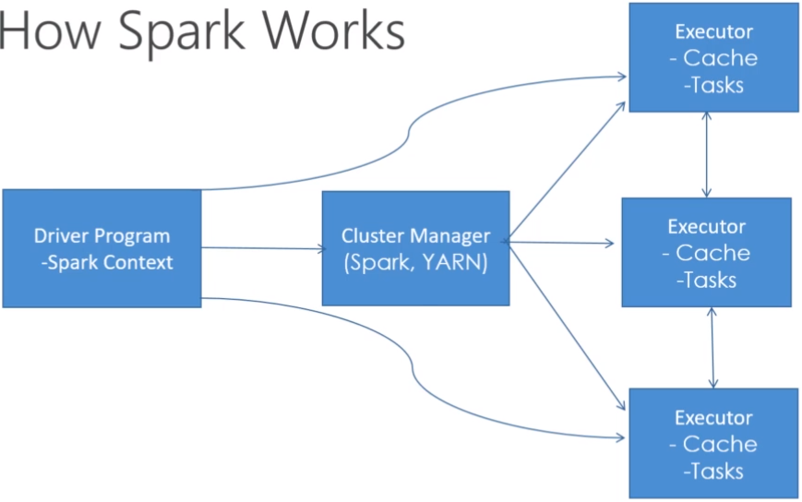

* Components of Spark:
  + Spark Core - Memory management, distribution, fault recovery, scheduling, monitoring jobs, and interacting with storage. Uses RDD (Resilient Distributed Datasets) that represents a large collection of data partitioned across compute nodes.
  + Spark SQL - Provides low latency interactive queries 100x faster than MapReduce. Includes cost-based optimizer, columnar storage, and code generation for faster queries. Sports various data sources JDBC, ODBC, JSON, ORC, Parquet, HDFS, or Hive. Allows data to interact as DataFrame in python or Dataset in Scala.
  + Spark Streaming - Has real-time fast scheduling capabilities to do streaming analytics. Supports mini-batch ingestion from Twitter, Kafka, Flume, HDFS, and zero MQ, and can also integrate with AWS Kinesis. Allows querying on streaming data as querying on a database using Spark Dataset.
  + 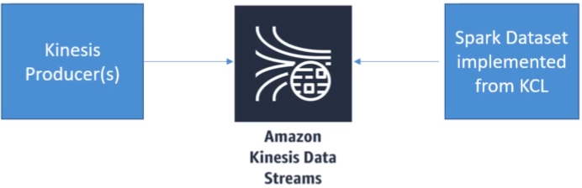
  + MLLib - Machine Learning analytics library providing libraries for different models and pre-processing that work in a distributed and scalable manner. For Classification, we have Logistic regression, naive bayes, Regression, Decision trees, Recommendation engine (AlternatingLeastSquares), Clustering (KMeans), Latent Dirichlet Allocation (topic modeling), workflow utilities such as feature transformation, SVD, PCA, stats, etc.
  + GraphX - Distributed graph processing framework (eg. people in the social network). Provides ETL, EDA, and interactive graph computation to build, and transform graph data structure at scale.

**2.7.3. EMR Notebook**

* Similar to Zepplin, it has more integration with AWS.
* Notebooks are backed up in S3.
* Allows provisioning of clusters through the notebook.
* It is hosted inside VPC and outside the EMR cluster.
* Accessed online via console.
* Use cases: build apache spark applications distributed over clusters and run queries on them.
* Support Python, PySpark, SparkSQL, SparkR, and Scala. Can be prepackaged with graphical libraries from Anaconda for prototyping of code, visualization, EDA with Spark Dataframes, etc.
* Allow multiple users from an organization to create multiple notebooks and attach them to shared multi-tenant EMR clusters and do collaborative work.
* No additional charges for the EMR notebook.

**2.7.4. EMR Security**

* Use IAM policies to grant/deny permissions to users.
* Kerberos for strong authentication through secret-key cryptography.
* SSH (Secure Socket Shell) allows users to have a secured connection with cluster instances, and tunneling for web interfaces.
* IAM roles for ways to access/interoperate EMR with other AWS services.

**2.8. Feature Engineering**

* Process of applying the knowledge you have for the data to trim, create new, or transform (scaling, missing data treatment, outlier analysis) features (attributes of data eg. house price prediction feature can be no. of rooms, area, no. of floors, etc) that are relevant to train the model better.
* Dimensionality refers to the number of dimensions. Each feature (single column) is treated as one dimension.
* If there are a large number of dimensions in a data it will lead to more complexity and sparse data. Though adding complexity may make the model’s performance better but using too many irrelevant features for training will end up reducing the performance of the model.
* To deal with this curse of dimensionality, we have various techniques that are used to select relevant features or get the essence of relevant features.
  + PCA (Principal Component Analysis)
  + KMeans Clustering

**2.9. Imputing Missing Data**

* Replace numerical feature column missing values with the mean of not null values in a feature.
* In case we don't want the effect of outliers, then the median might be a better choice.
* Mean and median are only column-level they won’t consider correlations between features, won’t work for categorical features (can consider mode but not efficient), and are not so accurate.
* Dropping missing rows is another quickest option but useful only if after dropping missing values we still have enough data and it doesn’t bias the data i.e. relationship between features is not that compromised to result in less accuracy. Not the best approach.
* Substituting the values of one column with the missing values of another column might be a better approach (eg. Substituting missing full-text review with summary review).
* From the production point of view, using a machine learning model to impute missing values is the best approach.
  + We can use KNN which finds K no. of nearest (most similar rows) and averages their values if we are dealing with numerical data,
  + Deep learning models are best for imputing missing categorical values but are quite complex, or
  + Regression for finding linear/non-linear relationships between a missing feature and other features eg. MICE (Multiple Impute by Chain Equation).

**2.10. Dealing Imbalanced Data**

* In a classification dataset, we might sometimes find that there is huge difference between no. of rows present in different categories i.e. positive and negative cases (eg. fraud detection no. of frauds are rare).
* In this case, the model may not predict one class at all and predict the other class at all times even though the accuracy is good the model is still not performing well for predicting the minority class.
* One of the methods dealing with this problem is oversampling the minority class data, this technique will simply copy the minority class rows at random until no. of rows in both the classes are kind of equal.
* Undersampling is another technique that simply means removing some of the majority class data to balance the no of rows in each class. This is not the best approach since it requires throwing out some data that may be important.
* One of the best approaches to handle imbalanced data is SMOTE (Synthetic Minority Oversampling Technique) which artificially creates new data for the minority class by taking K nearest neighbors of each sample of the minority class and creating a new sample by averaging the neighbors. It not only oversamples minority class but also undersamples majority class data.
* Another technique is adjusting the threshold for the probability that a sample belongs to a class (eg. a probability of more than 50% consider it a positive case). For eg, if there are too many false positives (not fraud but predicted as fraud) one way to fix the problem is to increase the threshold for the probability which will result in reducing false positives at the cost of an increase in false negatives (fraud but predicted as not fraud).

**2.11. Handling Outliers**

* Variance - Spread of data from its mean (Sum((val - mean) sq.) / num of val).

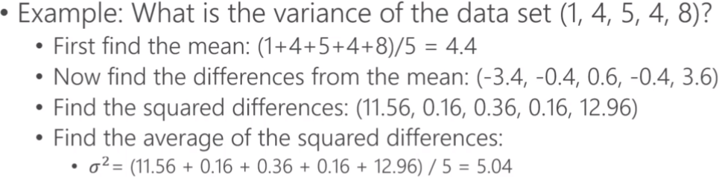

* Standard Deviation - Square root of variance.

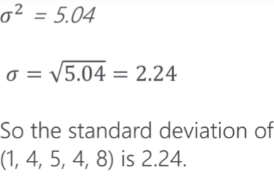

* Mean +/- Standard Deviation = In a range of normal distribution and mean. Data points that are outside the range are identified as outliers (within 1 standard deviation from the mean in general).
* We can also choose how many standard deviations from the mean are we considering for identifying an outlier.
* Outliers can also be detected using the Interquartile range (IQR = Quartile3 - Quartile1) anything outside the range between Quartile1 - 1.5 * IQR and Quartile3 + 1.5 * IQR are generally considered outliers.
* One of the methods of dealing with models is simply removing them if they are not that important. Eg. in case of malicious activities on a website detected through weblogs you want to fetch those outliers rather than remove them, but in the case of getting the average income of the people in a country, we might want to remove those outliers if they are not so consistent.
* AWS uses a random cut forest algorithm in many services like Quicksight, SageMaker, Kinesis Analytics, etc for outlier detection.

**2.12. Binning**

* Transforming numerical data into categorical data by bucketing these data based on the range of values (eg. grouping people in age 20s together, 30s together).
* Way of covering imprecision in measurements (eg. age 23.38 won’t add any info or seem incorrect). Can also be used in case the model we selected needs to deal with categorical data.
* Quantile binning categorizes the data based on its place in the data distribution such that each category range (bin) has an equal number of samples.

**2.13. Transformation**

* Logarithmic transformation of exponentially trending non-linear data into linear data is one form of transformation done in case we want to use a model that deals with linear data.
* Transformation does not necessarily mean replacing the existing feature it simply means feeding in both original as well as transformed feature to the model.

**2.14. Encoding**

* Transforming data into new representation required by the model.
* One-hot encoding is one type of encoding that uses 1 to represent that the data belong to category and 0 for data not belonging to the category.
* For eg, handwritten digit recognition 0-9, in the below diagram we can see 8th position is marked as 1 rest are marked as 0.

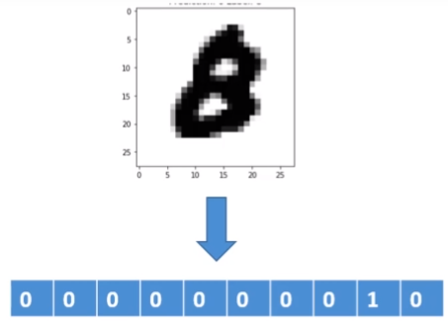

**2.15. Scaling/Normalization**

* Scaling or normalizing the feature is a technique that is used either when we want the data to be normally distributed (lie around average value).
* It is also used when the features have a huge range of differences between them such that a feature that has a larger magnitude of values will have more weight and impact on the training model than the other one i.e overpower other feature (eg. age of a person is 30 and income is 50000, income will have more weight and impact although it may not have much relevance than the other one).
* The scikit-learn preprocessing module of python has many scaler functions such as MinMaxScaler, and StandardScaler.

**2.16. Shuffling**

* Shuffling of data is done in case when the order of collecting data affects the splitting and training of the model where the model might train with residual signals rather than quality data resulting in bad performing model which can be overcomed by simply shuffling the data and then splitting and training the model.

**2.17. Ground Truth**

* Sometimes you might not have training data at all such as image classification where humans have to label the image data for training indicating what is there in the image (eg. soccer ball or basketball).
* Ground Truth basically manages humans that are going to label the data for training purposes, and it also creates its own model as it learns from labeled data and ambiguous data are sent to the human labelers.
* AWS Mechanical Turk, internal team, or professional labeling companies can be human labelers.
* Labeling can also be done by AWS Rekognition service for image classification of general objects in the world, and Comprehend service for topic modeling and text analysis that classifies text by topics, or sentiments.
* Ground Truth plus - Using a Turnkey solution where someone from AWS is hired to set up and manage the whole project of labeling by simply filling out a form.

**2.18. TF-IDF (Term Frequency Inverse Document Frequency)**

* Useful for searching purposes.
* Finds out how relevant a term is in a document (can be an article, paragraph, sentence, etc).
* The TF-IDF scores for each document in a corpus (collection of documents) help us figure out which documents are relevant for the search term.
* Term Frequency refers to how often a term occurs in a document and Document Frequency refers to how often a term occurs in an entire set of documents. (eg. common terms that occur across entire Wikipedia or all web pages like ‘a’, ‘the’, ‘and’, etc).

TF-IDF = TermFreq / DocFreq or TermFreq * InverseDocFreq (DocFreq raise to -1)

* In practice, the log of IDF is taken into consideration rather than the raw value because of the frequency’s exponential distribution.
* Limitations: Parses document as a bag of words but the relationships between the words are not taken into consideration so much, synonyms/ tenses/ abbreviations/ misspellings/ capitalization can be problematic too.
* Apache Spark can be used for dealing with the problem of computing the scores at scale.
* There are times when instead of individual words bigrams (2 words that occur together) or n-grams (n sequence of words occur together) are also considered.

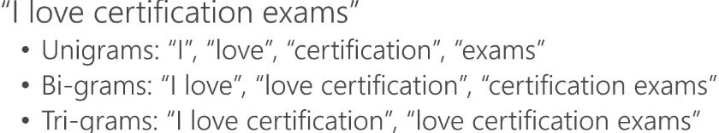

* Sample TF-IDF with unigrams and bigrams

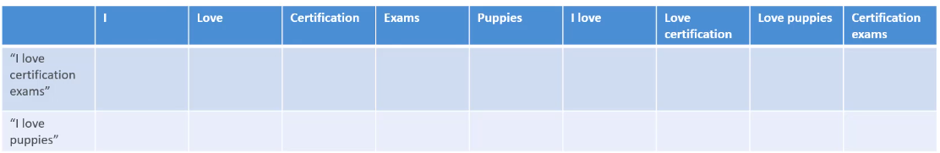

* Use in a simple search algorithm: Compute TF-IDF scores for every word in a corpus, for a given search word sort the documents as per their TF-IDF scores for that word, and at last display the results.

**3. Modeling Part I: ML & DL**

**3.1. Deep Learning**

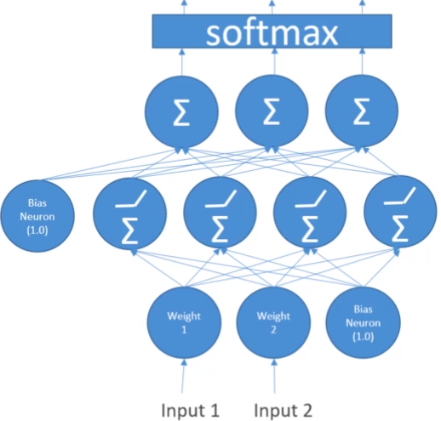

* In Deep Learning, the neural network is a type of network that tries to replicate the human brain in order to solve a problem.
* Like a human brain, a network has multiple layers of neurons (perceptron) that are connected to each other where input is passed to neurons, the summation is performed using randomly selected weights and biases, and at last, an activation function (eg. softmax - for multi-class classification) is applied to give the final result.
* Selecting appropriate weights and bias is important for getting desired results, that is why the algorithm runs for various epochs (similar to an iteration).
* The entire process happens in parallel i.e. neurons run in parallel using GPU architecture.
* Python libraries: Tensorflow (by google), Keras, MXNet (most AWS ML services use MXNet).
* Types of the neural networks:
  + Feedforward - General neural network working in one direction.
  + Convolution Neural Network (CNN) - Image classification.
  + Recurrent Neural Networks (RNN) - Deals with sequences of data such as textual sentences for sentiment analysis, translation, etc. Types of RNN - LSTM (Long Short Term memory), GRU (Gated Recurrent Unit).

**3.2. Activation functions**

* Function inside node/neuron that sums up all the input and decides what output should be sent as a result to another neuron.
* Linear activation function - Takes the input and sends the same input as the output. No backpropagation because no learning and optimization can be done by mirroring the input.

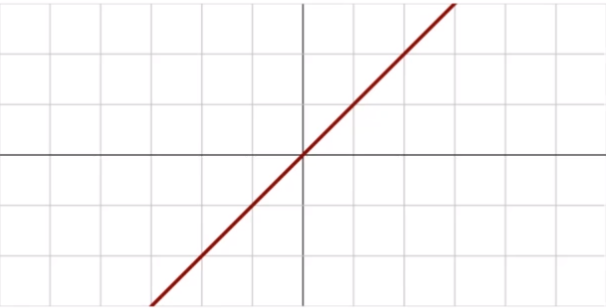

* Binary step function - Gives single on/off output. Either gives positive output or nothing.

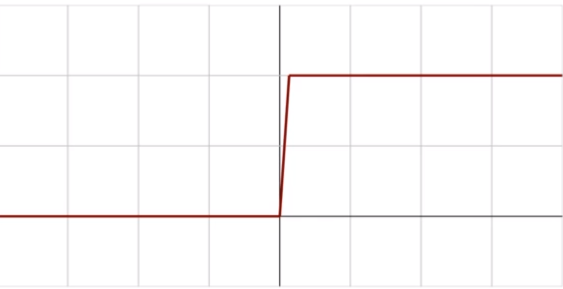

* Non-linear functions are mostly used because they can create complex mappings between input and output and do complex calculations, they can backpropagate to optimize the model (update weights and bias), and allow multiple layers of neurons.
* Sigmoid/Logistic function is a non-linear activation function used for binary classification that scales everything between 0 and 1 (probability).

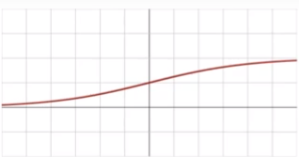

* TanH (tan hyperbolic) scales everything between -1 and 1 which is often used more in practice. Well-suited for RNNs.

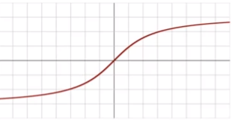

* The problem with sigmoid/tanH is a vanishing gradient in which as we go to the extreme positive or negative values the output changes slowly i.e learning happens slowly which results in numerical calculations being less precise. They are also computationally expensive (because of tangents).
* Rectified Linear Unit (ReLU) activation function is a fast and easy-to-compute function (not expensive for linear) that gives us non-negative results. The problem with ReLU is when the output is 0 or -ve we get a linear function (0 as output) called the Dying ReLU problem which can be overcome by Leaky ReLU with a negative slope.

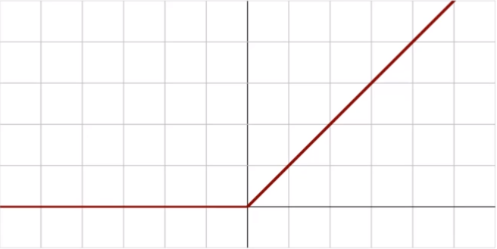

ReLU



Leaky ReLU, the -ve slope is closer to the horizontal line.

* Parametric ReLU (PReLU) learns the best negative slope via backpropagation. The problem is that it is complicated and computationally intensive.

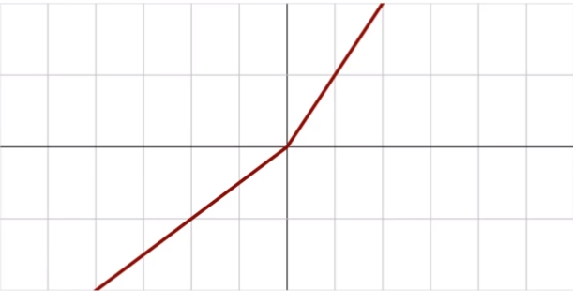

* Exponential Linear Unit (ELU) is similar to Leaky ReLU, the only difference is the exponential curve -ve slope (good for calculus derivatives).

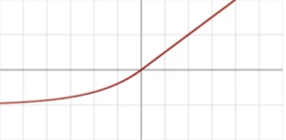

* Swish activation function (by Google) is a great alternative to ReLUs and is a benefit to a very deep neural network with more than 40+ layers.

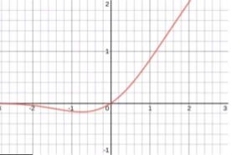

* Maxout activation returns the maximum of all of the inputs that came into the node. Doubles the number of parameters (weights or bias) i.e. not practical in practice makes the network expensive.
* Softmax activation function used as an output layer for multi-class classification neural network. Takes output from the last layer and converts it into probabilities (for each class) and then we can select the class output with maximum probability.

**3.3. CNN**

* Used for finding or scanning unique features/patterns (feature location invariant) in the data. Used mostly for image classification.
* Other use cases: Machine translation, sentiment analysis, sentence classification, etc.
* Input Layer **-** This layer consists of Images in the form of pixels of shape (height, width, color channels (RGB)).

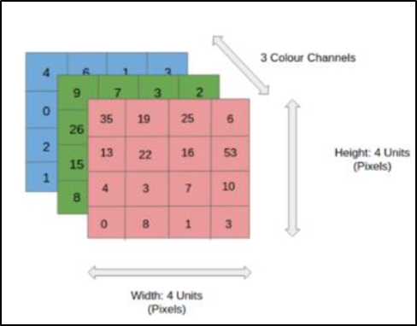

* Convolutional Layer - A filter/kernel that is in the form of a matrix scans a few pixels at a time and creates a feature map (features - edges, lines, shapes, etc) that predicts the class to which each feature belongs.

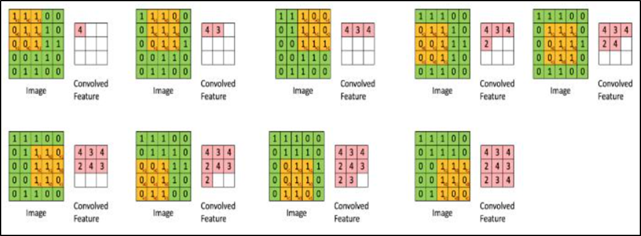

* Pooling Layer **-** This layer reduces the amount of information in each feature that was obtained in the convolutional layer while maintaining the most important information. Several types of pooling that are used are:
  + Max pooling calculates the maximum value for each patch of the feature map.
  + Average pooling that calculates the average value for each patch of the feature map.
  + Global Max pooling calculates the overall maximum value for the feature map.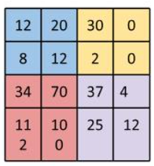

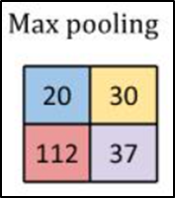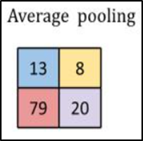

* Batch Normalization Layer -This layer helps to coordinate the update of multiple layers in the model. It scales the output of the layer, specifically by standardizing the activations of each input variable per mini-batch.
* Dropout Layer -This layer is used to simulate having a large number of different network architectures by randomly dropping out nodes during training. This is an effective regularization method to [reduce overfitting and improve generalization error](https://machinelearningmastery.com/introduction-to-regularization-to-reduce-overfitting-and-improve-generalization-error/) in deep neural networks of all kinds.
* Flatten Layer - This layer converts the multi-dimensional output to a 1D vector of pixels.
* Dense Layer - A dense layer is a layer that is deeply connected with its preceding layer which means the neurons of the layer are connected to every neuron of its preceding layer.
* Keras/Tensorflow library has modules for each layer such as Conv1D/Conv2D (Image)/Conv3D (Video) from Keras as per dimensions, MaxPool2D, Flatten, Dropout, Dense, etc.
* Typical usage:



* Resource intensive (heavy on CPU/GPU/RAM) with lots of hyperparameters to adjust such as filter/kernel size, number of units/neurons required in each layer, choice of the optimizer, activation function, etc which makes it very difficult.
* We can reduce the problem of tuning the hyperparameters by using transfer learning i.e. trained CNN neural networks such as LeNet5 (handwriting recognition), AlexNet (Image classification), GoogLeNet (Deeper network with inception modules of grouping convolutional layers), ResNet (Residual Network that maintains performance via skip connections).

**3.4. RNN**

* Used for data with arbitrary length of sequences such as Time series web logs, sensor logs prediction, translation, image captions, machine-generated music (sequence of notes), etc where the order of data or words matters.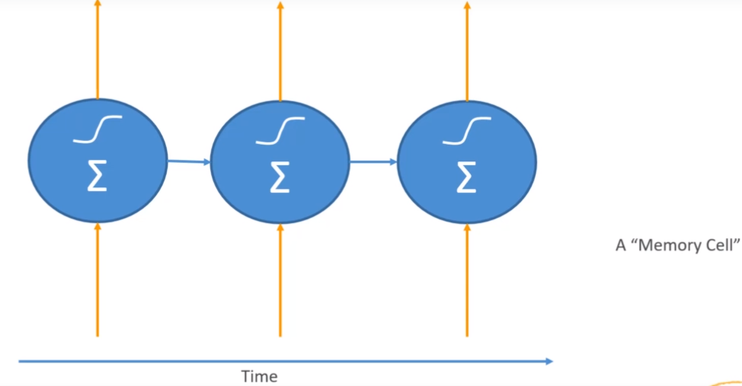

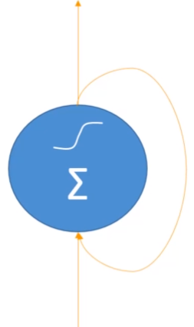

* Input or/and the output from the previous neuron is fed to the neuron, summation and activation function is applied and the result is not just passed on to the next neuron it is also fed back to the current neuron to preserve the sequence of data.
* Each recurrent layer can have multiple neurons.
* RNN has the hidden state that has information about the sequence and memory used to capture the calculations made so far over time.
* Each successive step from one neuron to another is called a time step.
* The problem (for some applications) is that the earlier behaviors are diluted and the recent behaviors have more influence on the current time step. This can be overcome by the LSTM cell that maintains separate long-term and short-term states, or the GRU cell which is the optimized and simpler version of LSTM.
* RNN topologies:
  + Sequence to Sequence - Time series to time series such as predict stock prices based on historical data.
  + Sequence to Vector - Words in a sentence to a sentiment (hate/love/happy/sad).
  + Vector to Sequence - Captions from images.
  + Encoder > Decoder - (Seq to Vect to Seq) Sentence to meaning to translation.
* Training RNNs can be harder than CNN because unlike CNN it not just has to backpropagate through layers but also adds up the time steps which can look like another layer of time steps itself. We will end up having a very deep neural network (gradients calculated for weights or bias updates can cost very large).
* Truncated backpropagation method of limiting no. of time steps can be used to overcome the problem.

**3.5. Deep Learning EMR/EC2**

* EMR supports Apache MXNet and various GPU instances.
* Some of the appropriate instance types can be P3: 8 (Tesla), P2: 16, or G3: 4 (Nvidia).
* Deep learning AMIs are available where we can deploy an EC2 instance with DL framework preinstalled such as Tensorflow, MXNet, etc on instance types.

**3.6. Tuning Neural Networks**

* Learning rate tells us how quickly the algorithm learns or how quickly it updates the parameters (weights, bias) using gradients (partial derivatives) over epochs, in order to minimize the cost/loss function (eg. misclassification error) and maximize performance (eg. accuracy).
* If the learning rate is too high, it overshoots the optimal solution (eg. global minimum of loss) and if the learning rate is too low it will take too much time to reach the optimal solution i.e. more training time than needed.
* This learning rate is one of the hyperparameters that can be adjusted while training our model. The difference between parameter & hyperparameter is that parameters are learned by the model and hyperparameters are default or adjusted by us.
* Batch size refers to the number of training samples used within each batch within each epoch. Smaller batch sizes help us get out of the local minima (local optimal solution), and if the batch size is too large we can end up getting stuck in the same at random.
* Random shuffling is done at the start of each epoch which can give different results at different runs and different hyperparameters.

**3.7. Regularization**

* Prevents overfitting where overfitting happens when there is a huge difference between training and testing/evaluation dataset performance (eg. accuracy) i.e. model learns irregular patterns/noise.
* The training dataset is a dataset with which our model is trained, evaluation is a dataset with which the model is evaluated alongside training at each epoch, and testing is the dataset with which the model’s performance is tested for the new data.

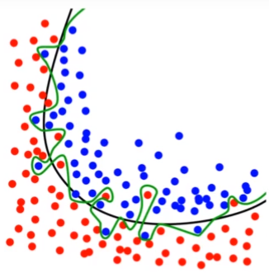

The green line indicates that the model is overfitting i.e. learning noise.

* The simplest regularization technique is to use fewer neurons or fewer layers for the neural network making it a simpler model.
* Using the Dropout layer is another regularization technique that drops neurons or nodes at random at each epoch forcing the learning to spread itself preventing individual neurons to overfit to a specific data point.

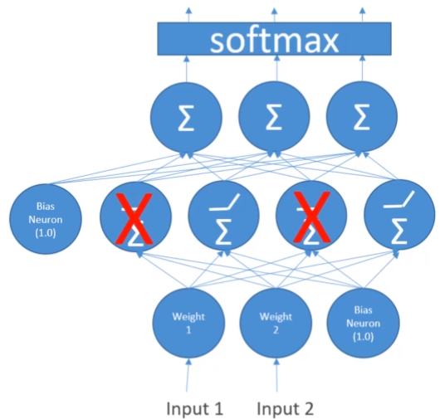

* Early stop technique is a technique that stops the model from training after some epochs if the increase in epochs is making the performance worse than better,
* L1 and L2 regularization add regularization terms as weights. Often used when overfitting is due to the inclusion of irrelevant features.
* L1 (sum of weights) performs feature selection where the irrelevant features end up having regularization term 0. It is computationally inefficient and gives sparse output. Use case: reducing dimensionality from 100 features to 10 features.
* L2 (sum of square of weights) considers all the features and weights the features as per their relevance. It is computationally efficient with dense output. Use case: features are important and can be used in the future for other purposes.

**3.8. Gradient problem**

* Vanishing gradient is a problem that occurs when we train a very deep neural network at the time of backpropagation we have to go back all the way back to the initial layers and calculate gradients for each weight and bias. (especially in the case of RNN)
* These gradients can be so small due to multiple calculations/chain multiplications (<1) that they shrink exponentially and vanish.
* The opposite of the vanishing gradient is exploding gradient where gradients have large values (>1) that they eventually blow up and crash the model.
* We can fix the vanishing gradient using
  + Multi-level hierarchy of layers where the neural network is broken into sub-neural networks and then trained individually.
  + LSTM
  + ResNet, Ensemble short networks
  + Better choice of the activation function (eg. ReLU)
  + Gradient checking - Debugging technique to numerically check the derivative i.e. gradients during training.

**3.9. Confusion matrix**

* See the performance of a classification model in detail in matrix form actual vs predicted.
* For eg, whether the patient is diagnosed with a disease or not.

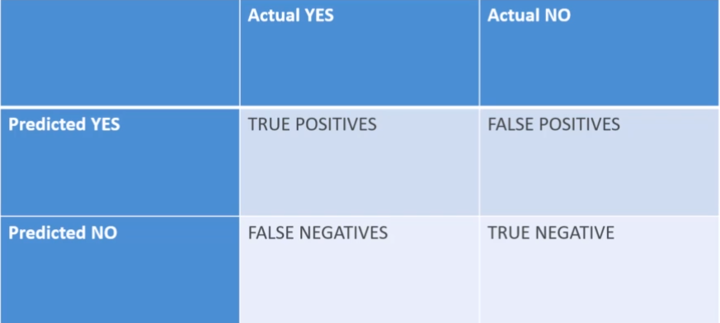

* True positive - predicted the patient is diagnosed with the disease it actually is.
* True negative - predicted the patient is not diagnosed with the disease and is not.
* False positive - predicted the patient is diagnosed with the disease but is not actually.
* False negative - predicted the patient is not diagnosed with the disease but actually is.
* Each value in the matrix gives represents no. of rows or data.
* The more values on the True diagonal and fewer values on the False diagonal better the model is.

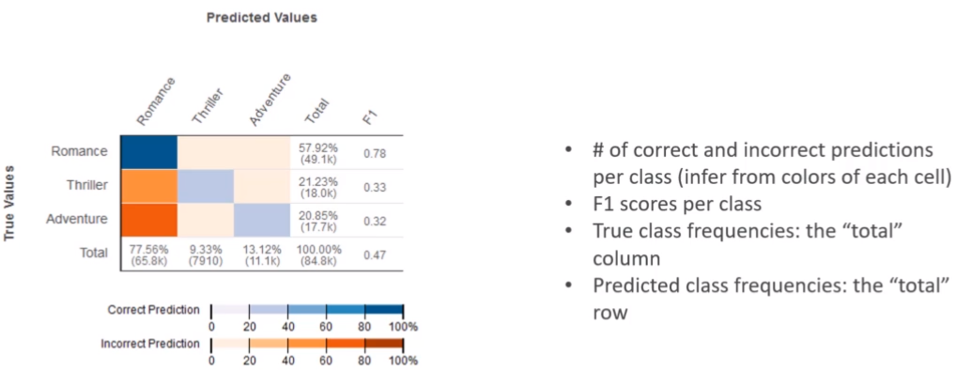

**3.10. Recall/Sensitivity**

* True positive rate.
* Percentage of positive predictions that we were able to catch.
* True positive / (True positive + False negative)
* Good choice of metric in case we care about false negatives (eg. fraud detection).

**3.11. Precision**

* Percentage of correct positive predictions (relevant results).
* True positive / (True positive + False positive).
* Good choice of metric in case we care about false positives (eg. medical screening, drug testing).

**3.12. Specificity**

* True negative rate.
* True negative / (True negative + False positive).

**3.13. F1 Score**

* Test accuracy.
* Harmonic mean of precision and recall, 2 * (Precision * Recall) / (Precision + Recall).

**3.14. RMSE (Root Mean Squared error)**

* The positive square root of the sum of the square of the difference between predicted and actual values.
* Accuracy measure.
* Only cares about right and wrong values.

**3.15. ROC (Reciever Operating Characteristic) curve**

* A tradeoff between sensitivity and specificity.
* More the curve is closer to the upper left corner in a ROC space away from the diagonal the better the model is.
* Evaluates the accuracy of the classification model.

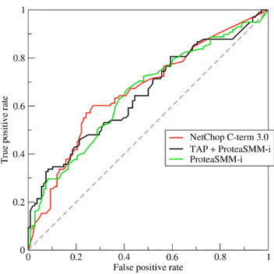

* AUC (Area under the curve) is the measure of test accuracy which represents the probability that a classifier will rank a positive instance higher than a randomly chosen negative one.

**3.16. Ensemble Learning**

* The ensemble method is a method that combines the results from multiple base learners/models (eg. decision tree) in order to give one optimal result (eg. random forest).
* Bagging - Randomly selecting training sets of samples with replacement and training multiple base models using them in parallel. Overcomes the problem of overfitting. The final result is either an average of all results or based on the maximum voted class.

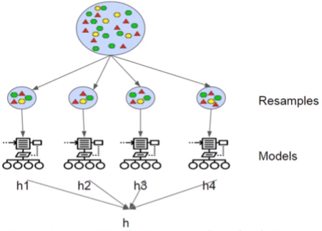

* Boosting - Sequential model (output of one model is fed as an input to other). Observations are weighted, these weights are updated, and based on the weights some observations take part in the training and some do not. Each model corrects the errors of the previous model yielding better accuracy.

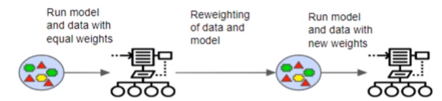

**4. Modeling Part II: Amazon SageMaker**

**4.1. Amazon SageMaker**

* Manages the entire ML workflow.
* ML phase:
  + Fetch, clean, and prepare the data.
  + Train and evaluate the model.
  + Deploy model and evaluate results in production environment.

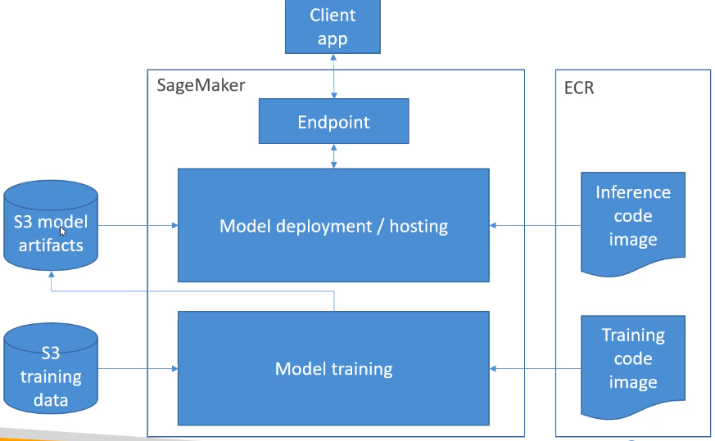

* Process:
  + Training data comes from S3 bucket. SageMaker provisions bunch of training hosts.
  + Actual code for the model comes from docker image registered in Elastic container Registry, and the code is deployed to the hosts for training.
  + The trained model and any artifacts from it, is saved to the S3 bucket.
  + The model is deployed to production.
  + The inference code docker image takes the incoming requests from the client, uses the saved model to make inferences based on that request, and sends the response back to the client.
* We can work with SageMaker using a Notebook that runs on EC2 instances. It has access to many built-in modules, and libraries like Tensorflow/scikit-learn/spark, S3 data. Training instances (server) can be spinned up through the notebook itself. Deploying the saved model, and making predictions at scale can be done via notebook. Supports automated hyperparameter tuning to get optimal hyperparameters.
* The data format from S3 depends on the algorithm and it is often RecordIO/Protobuf for built-in algorithms.
* We can use the algorithms purchased from AWS Marketplace, Spark MLLib, built-in, and Docker image, custom code.
* To create a training job, we may need the URL to S3 for training/output, ML compute resources, and ECR path for the training code.
* While deploying the model, we also get options to use inference pipelines for complex processing, SageMaker Neo for deploying model to edge devices, Elastic inferences for accelerating DL, Automatic scaling for endpoints, etc.

**4.2.** **Linear Learner**

* Linear Regression - Used for prediction of numerical quantity when there is a linear relationship between dependent and one or more independent variables i.e. when we plot features against the label an approx. a straight line can be drawn.
* Linear threshold function for classification (binary/multi-class).
* Input can be RecordIO-wrapped protobuf (float32 only), CSV file with 1st column assumed as the label. Input data must be normalized manually or automatically and shuffled.
* Supports file (entire training data into one file) and Pipe (data passed in the stream through S3).
* Trains multiple models and uses optimization algorithms using SGD, Adam, or AdaGrad in parallel. Allows tuning L1, and L2 regularization.
* Allows hyperparameter tuning of balance_multiclass_weights, learning rate, L1, L2 (weight decay), etc.
* Resources must be one or more CPU and a GPU.

**4.3. XGBoost (eXtreme Gradient Boosting)**

* Boosted group of Decision trees.
* New trees are added to correct the errors of previous trees.
* Gradient descent is used to minimize the loss (error).
* Open-source fast algorithm.
* Also used for regression.
* Supports CSV, Libsvm, Parquet, and RecordIO-Protobuf.
* Serialized and deserialized with Pickle.
* Can be used as a SageMaker framework within Notebook or as a built-in SageMaker algorithm referring XGBoost from Docker image in ECR for large-scale training jobs.
* Hyperparameters:
  + subsample - to prevent overfitting, eta - step size shrinkage that prevents overfitting.
  + Gamma - minimum loss reduction to create a partition for new branch of the tree (larger more conservative model).
  + Alpha - L1 regularization (larger more conservative model).
  + Lambda - L2 regularization (larger more conservative model).
  + max_depth - Limit the depth or level of the tree to prevent overfitting.
  + scale_pos_weight - adjusts the balance of +ve and -ve weights in case of imbalanced data.
  + eval_metric - Metrics for evaluation of model by optimizing on AUC, RMSE, error, etc.
* CPU training is preferred in the case of multiple instances and for a single instance (eg. M5), GPU training can be used which is a faster and can be cost-effective method (eg. P3) but we have to set hyperparameter tree_method to gpu_hist.
* CPU training only for XGBoost 1.0 and for XGBoost >= 1.2 version GPU training is allowed.

**4.4. Seq2Seq**

* Inputs sequence of tokens and gives output as a sequence of tokens as well.
* Use case: Machine translation, text summarization, speech to text, etc.
* Implemented with CNNs or RNNs with attention.
* Input is RecordIO-Protobuf (tokens are mapped integers) format.
* We need to provide training, validation tokenized text files along with vocabulary files that map tokens with their integer values.
* Sample code available to convert into Protobuf i.e. tokenized text to integer tensors vocabulary file.
* Ordinary model training let's say translation tasks take days for training in that case we can use pre-trained models and public training datasets for specific tasks (eg. english to a german dictionary for translation).
* Hyperparameters: batch_size, optimizer_type (adam, sgd, rmsprop), learning_rate, num_layers_encoder, num_layers_decoder, and for translation we can compare accuracy for training and validation sets, blue score for comparing with reference translations, perplexity (cross-entropy), etc.
* Single machine with multiple GPUs is allowed (eg. P3).

**4.5. Deep AR**

* Forecasting 1D time series data that uses RNN.
* Allows training of the same model at different time series that are related or interconnected with each other.
* Finds frequencies and seasonality.
* Inputs JSON lines format (can be GZip or Parquet).
* Each record must have a start timestamp and target time series.
* Optionally we can also pass dynamic and categorical features.



* Include the entire time series (time-dependent feature over time) for training, testing, and inference because the model will be for 1-year lag at a minimum anyhow.
* Use the entire dataset as a test set just remove the last time sets for training and evaluate the withheld values.
* Don’t use very large values (>400 time points) for prediction length i.e. predicting the future.
* Hyperparameters:
  + context_length - no. of points back model sees before making predictions. Can take smaller than seasonalities.
  + epochs - no. of iterations (from input to all the layers, updating weights will be 1 epoch).
  + mini_batch_size
  + learning_rate
  + num_cells - no. of neurons.
* Allows both CPU (c4.2xlarge, c4.4xlarge) and GPU instances on single or multiple machines. CPU instances are cheaper and are preferable in the case of making inferences from the pre-trained model. Larger instances are preferable in case hyperparameter tuning jobs.

**4.6. Blazing Text**

* Used for supervised text classification predict labels for sentences (eg. web searches, information retrieval). Only works on sentences, not documents.
* Used for Word2Vec which creates an embedding layer that groups similar words together (eg. machine translation, sentiment analysis). Only works for words, not sentences/documents.
* For supervised mode, it takes 1 sentence per line as input with the first word as __label__ followed by the actual label (called augmented manifest text format).

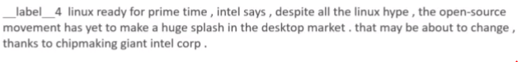

Words separated by space

* For word2vec mode, it takes a text file with 1 training sentence per line.

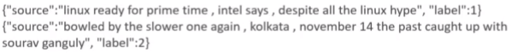

* Word2Vec modes:
  + Cbow (continuous bag of words) - Bag of words is a feature extraction method for text that records the frequency of words in a document and doesn't care about the sequence/order of words. Cbow predicts the probability of a word for the given context.
  + Skip-gram - takes a word as input and predicts the 2 representations of context.
  + Batch skip-gram - skip-gram in a distributed manner (computation over CPU nodes).
* Hyperparameters:
  + Word2vec - mode (cbow, skipgram, batch_skipgram), learning_rate, window_size, vector_dim, negative_samples.
  + Text classification - epochs, learning_rate, word_ngrams, vector_dim.
* For cbow and skip-gram p3 nodes on CPU or GPU instances on single machines are recommended, for batch skip-gram CPU instances on multiple machines are allowed, and for text classification C5 for less than 2GB data and single GPU instance for larger data sets are allowed.

**4.7. Object2Vec**

* Embedding layer to group arbitary objects (eg. documents) that are similar to each other.
* Create lower dimensional embedding using features/attributes of higher dimensional objects (using vector representation).
* Gets nearest neighbors for clustering and visualize clusters.
* Use case: genre prediction, recommendation (items, user, etc).
* Input data is tokenised into integers.
* Training data may consist pairs or/and sequences of tokens (eg. sentence-sentence, labels-sequence, customer-customer, product-product, user-item, etc).



* Process input data into JSON lines and shuffle it for training.
* Each components in a pair train in 2 path of input channels in parallel. These input channels has its own encoder. They are further fed into a comparator that generates the ultimate label.
* Encoder choices: Average pooled embeddings, CNNs, Bidirectional LSTM.
* Comparator is followed by feedforward neural network.
* Hyperparameters: Dropout, early stopping, epochs, learning rate, batch size, layers, activation function, optimizer, weight decay, enc1_network, enc2network (hcnn, bilstm, pooled_embedding).
* Single machine with one or multiple GPU instances, p2 2x mode for inference and it is recommended to use Inference_preferred_mode to set up inference image and optimize encoder embeddings rather than both classification and regression.

**4.8. Object Detection**

* Used to detect object and assign classes of what they are along with confidence scores for surity/probability. Each object is surrounded by bounding boxes to pinpoint their locations.
* Train model from scratch using own training data (maybe labeled by GraoundTruth) or use pretrained models based on imagenet.
* Input can be RecordIO or Image file (jpg, png) along with JSON file for annotation data for each image.

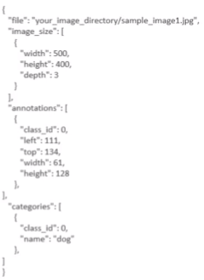

* An object in the image can belong to more than one class/category for ambiguous situations.
* Uses CNN (VGG16/ResNet50) along with Single-shot multi-box Detector algorithm (SSD).
* Allows Transfer learning mode that takes the base layers as pre-trained model layers (with base network weights instead of random weights) and use your own layers along with it.
* Uses flip, rescale or jitter to avoid overfitting.
* Hyperparameters: mini_batch_size, learning_rate, optimizer (sgd, rmsprop, adadelta).
* Multiple GPU instances on single or multiple machines for training can be used and CPU for inferences.

**4.9. Image Classification**

* Assigns labels to the image indicating what’s in the image without acknowledging its location.
* Input data can be RecordIO with no Protobuf format, Image file (jpg, png) along with .lst files to associate image indes, class label and path to image file.
* Also supports augmented manifest image format that enables pipe mode for streaming data ( from S3).

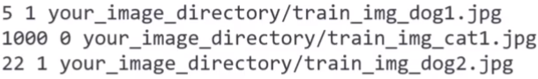



* Uses ResNet CNN.
* Supports fully training mode (own model with random weight), and transfer learning (pre-trained model with pre-trained weights) along with own model layers where fully connected top layers relearn and tune weights.
* Default size 3 channels of 224x224 pixels.
* Hyperparameters: batch_size, learning rate, optimizer (beta1, beta2, eps, gamma, weight decay).
* Multiple GPU with single or multiple machines for training, and CPU or GPU for inferences.

**4.10. Semantic Segmentation**

* Pixel level object classification (Which class a pixel belongs to).

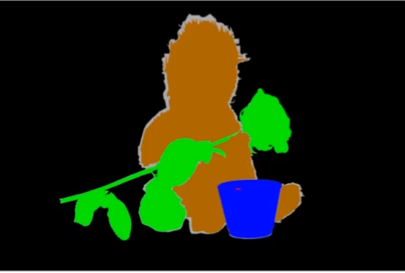

* Use cases: self-driving cars, medical imaging diagnostics, and robot sensing (where granularity of data matters).
* Produces segmentation mask as shown in the above image.
* Input data is JPG/PNG image files with annotation associated with them for both training and validation data, JPG for inference, and augmented manifested image format for pipe mode.
* Label maps to describe annotations.
* Uses MXNet Gluon and Gluon CV.
* Gives choices of 3 algorithms Fully-Convolutional Network (FCN), Pyramid Scene Parsing (PSP), and DeepLabV3, and 3 choices for architecture/backbone ResNet50, ResNet101 trained on Imagenet.
* Allows training from scratch or incremental training.
* Hyperparameters: epochs, optimizer, learnin rate, algorithm, backbone.
* P2 or P3 GPU instances for training on single machine and Inference on CPU (C4, C5) or GPU (P2, P3).

**4.11. Random Cut Forest**

* Unsupervised learning algorithm (no training) used for anomaly detection that detects unexpected spikes in a time series data. Developed by Amazon.
* Unexpected spikes can be breaks in periodicity, unclassifiable data points, etc.
* Each data points are assigned anomaly scores.
* Input data can be CSV, RecordIO-Protobuf format as a file or in pipe mode.
* Provides optional test channel for computing accuracy, precision, recall, and F1 on labeled data (anomaly or not).
* Creates a forest of trees by randomly sampling training data i.e. partitions from training data. It expects a change in complexity when a new data point is added (unexpected = anomalous).
* Can show up in Kinesis analytics and work with streaming data as well.
* Hyperparameters: num_trees (increasing reduces noise), num_samples_per_tree (chosen such that 1/num_samples_per_tree approximates ratio of anomalous to normal data).
* No GPU instances, use M4, C4 or C5 for training and C5 xl for inference.

**4.12. Neural Topic Model**

* Unsupervised learning algorithm that provides topics (what the context is about) for collection of documents.
* Classify or summarize documents based on topics.
* Group terms on higher level and tells us what those might represent (topics, eg. bike, car, mileage, speed might be classified as transportaions).
* Uses Neural Variational Inference algorithm.
* Four data channels: train, test, validation, auxiliary.
* Input data can be RecordIO-Protobuf or CSV format in a File or Pipe mode.
* Words must be tokenized into integers along with the vocabulary CSV file consisting count of a word present in the document using auxiliary channel.
* Number of topics is given where topics are nothing but latent representations based on top ranking words.
* Hyperparameters: mini_batch_size and learning_rate (low values can reduce loss but increase training time), num_topics, etc.
* GPU instance for training, CPU for inference.

**4.13. Latent Dirichlet Allocation (LDA)**

* Unsupervised Learning topic modeling algorithm (not DL).
* Groups documents based on shared subsets of words (can be other things) and assigns them a topic.
* Use cases: Cluster customers based on purchases, harmonic analysis in music.
* Train channel (analyzing data), optional test channel (measure performance using log-likelihood).
* Inputs can be recordio-protobuf (Pipe mode only) or CSV files along with a vocabulary file consisting of word count in a document (CSV).
* Works similar to Neural Topic Model where we have to mention number of topics but it is CPU-based (single instance) and is cheaper.
* Hyperparameters: num_topics, alpha0 - initial guess for concentration parameter (low value = sparse topic mixtures, high value > 1 = uniform topic mixtures).

**4.14. K-Nearest-Neighbors (KNN)**

* Supervised Classification and regression algorithm.
* For classification, it takes k nearest data points (based on some distance metric computed) into consideration and returns the most frequent label.
* For regression, it takes k nearest data points into consideration and returns the average value.

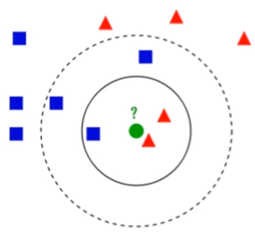

* Train and test channel.
* Inputs can be CSV (1st column label) or RecordIO-Protobuf format in a file or pipe mode.
* In SageMaker, the data is first sampled, dimensionality reduction is done at cost of some accuracy/noise (sign/fjlt methods can be used), build index for looking up neighbors at run time, serializes the model, and query the model for a given k.
* Hyperparameters: k, sample_size
* CPU or GPU instances for training and inference (CPU for low latency, GPU for high throughput).

**4.15. K-Means Clustering**

* Unsupervised Learning algorithm.
* Divides similar data points into k groups where similarity is measured by a distance metric (Euclidean distance).

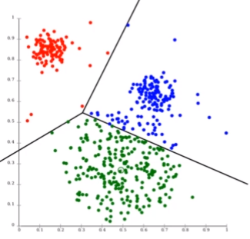

* SageMaker brings web large-scale k-mean clustering.
* Train channel (analyze), test channel optional. Provides options such as train ShardByS3Key (No replication), test FullyReplicated (Copy all train data).
* Inputs can be RecordIO-Protobuf or CSV format in file or pipe mode.
* Every observation is mapped to n-dimensional feature space, cluster center are chosen at random or chosen far apart using kmeans++, the model iterates over training data, calculates cluster centers and assigns data points to cluster centers, extra clusters can added to improve accuracy and is reduced to original number of k using Lloyd method.
* Hyperparameters: k (can be chosen using elbow method by plotting within-cluster sum of squares), mini_batch_size, extra_center_factor, init_method (random, kmeans++).
* CPU or GPU instances are supported, CPU is preferable, only one instance per GPU is supported.

**4.16. Principal Component Analysis (PCA)**

* Unsupervised dimensionality reduction technique to reduce the data from higher dimensional space to lower dimensional space while minimizing loss of information.
* Reduced dimensions are called components with 1st component having largest possible variability, 2nd has the next largest, and so on.
* Inputs can be RecordIO-Protobuf or CSV format in file or pipe mode.
* Creates a covariance matrix, and a singular value decomposition (svd) algorithm is used.
* SageMaker uses 2 modes: Regular for sparse data with fewer no. of observations and features, randomized for large no. of features and observation (uses approximation algorithm).
* Hyperparameters: algorithm_mode, subtract_mean (unbiasing the data).
* CPU or GPU instances.

**4.17. Factorization Machines**

* Classification and regression with sparse data (few information about the entity).
* Use case: click prediction of the user, product/page recommendation (mostly).
* Limited to pairwise interaction i.e. algorithm deals with 2D factorization matrix (eg. one dimension can be users other can be items to be recommended).
* Inputs must be RecordIO-Protobuf in float32 format.
* Huge sparse matrix with let’s say user and item information is given from which the algorithm finds factors that predict a class for classification (purchase or not), or value (rating).
* Hyperparameters: initialization methods for bias, factors, and linear terms (uniform, normal, constant).
* CPU recommended or GPU for dense data.

**4.18. IP Insights**

* Unsupervised learning algorithm that finds suspicious behaviour by looking at web logs for given usage patterns of IP addresses. It is used as a security tool.
* It can identify login attempts from anomalous IP addresses, identify accounts that are creating resources from anomalous IP addresses, etc.
* Inputs usernames and account IDs directly (no pre-process), CSV only with features entity and IP.
* Training channel, validation channel optional (AUC score).
* Uses neural network to learn latent vector representations of IP and entities (figure out IP address patterns), entities are hashed and embedded together trying to organize IP addresses together, and a sufficiently large hash size is needed.
* Automatically generates negative samples (anomalous) during training by randomly pairing IPs and entities to prevent the problem of imbalanced data.
* Hyperparameters: num_entity_vectors - hash size, set to 2x the no. of unique entity identifiers, vector_dim - the size of embedding vectors, scales the model (too large results in overfitting), epochs, learnin rate, batch_size, etc.
* CPU or GPU (recommended) instances. GPU > P2 2x large and CPU depending of num_entity_vectors, vector_dim.

**4.19. Reinforcement Learning**

* Developed by Amazon.
* Learning about some virtual environment (board/maze layout) and how to navigate through that environment in an optimal manner as different states (location of agents) of the environment are encountered.
* There is an agent that explores the space and trains itself by learning the value of different state changes under different conditions. Once it is trained, it is faster to deploy it and yield a fast online performance.
* Use cases: Pac-Man, Cat & mouse game (game AI), supply chain management, HVAC systems, industrial robotics, dialog systems, autonomous vehicles.
* One of the implementation of reinforcement learning is Q learning:
  + We have a set of environmental states ‘s’ (eg. ghost, power pill next to me), set of possible actions ‘a’ (eg. move in directions up, down) in those states, and a value for each state/action ‘Q’.
  + Starts with Q values of 0.
  + Explores the space.
  + If bad things happen after a given state/action, decrease the Q value, and if it opposite (rewards) increase the Q value.
  + These Q values inform the rewards associated for a given action at different states, are then used to predict agent’s future choices.
  + In case we want to look few steps ahead of the current state, we can use a discount factor when computing ‘Q’ based on how far away is the agent in time. The actions taken for the +ve action can be highly boosted using this computation.
  + This entire process is called Markov Decision Process or Discrete time stochastic control process.
* Exploration:
  + The simplest approach is that initially Q values are 0 and actions are taken in random. Once we get better Q values for given actions, we choose the action for a given state with highest Q value (random for tie). Cons: Inefficient and lose many paths to explore.
  + The better approach is introducing variation term epsilon. If the appeared random number is less than the epsilon, don’t follow the highest Q value and take an action at random. Exploration never stops although choosing epsilon can be tricky.
* Uses MXNet and Tensorflow and supports toolkits Intel Coach and Ray Rllib.
* Supports custom, open-source, and commercial environments such as MATLAB, Simulink, EnergyPlus, RoboSchool, PyBullet, Amazon Sumerian, and AWS RoboMaker.
* Training and environment rollout (deploy trained model) can be done in a distributed manner across machines. Allows both multi-core and multi-instance with GPU (recommended) or CPU.

**4.20. Automatic Model Tuning**

* We define different hyperparameters, their ranges, and metrics used for optimization.
* SageMaker then creates a hyperparameter tuning job that trains model with as many combinations of hyperparameters we want (upper bound on no. of training steps to control cost).
* It does not try every possible combinations, it learns as it goes i.e. intelligently chose parameters based on their previous +ve/-ve effects.
* The model can be trained with different parameters in parallel at separate instances.
* Once we produce the best performing model, we can deploy it.
* Best practices:
  + Don’t optimize too many hyperparameters at once.
  + Limit ranges as small as possible.
  + Use logarithmic scales when appropriate.
  + Don’t run too many training jobs in parallel/concurrently because it helps the process to learn better as it goes.
  + Correct objective metrics is being reported at the end of training jobs that run at separate instances.

**4.21. Apache spark with SageMaker**

* Spark can pre-process BigData datasets and generate dataframes.
* Spark and SageMaker can be integrated together using sagemaker-spark library that in turn lets us use sagemaker within the spark driver script.
* First we connect sagemaker notebook to EMR clusters running Spark (or use Zepplin).
* Training dataframe should consist of feature columns as vector of Doubles, and an optional label column of Doubles.
* Use SageMakerEstimator (access various ML libraries such as KMeans, XGBoost, PCA) to train the desired model to get a SageMakerModel.
* Use Transform to get inferences for SageMakerModel.
* Also allows to work with Spark Pipelines.

**4.22. SageMaker Studio, SageMaker Experiments**

* SageMaker Studio:
  + Visual Integrated Development Environment (IDE) for ML.
  + Can integrate with many features.
  + Integrate, create and share Jupyter Notebook with SageMaker Studio.
  + Allows switching between different resource configurations.
* SageMaker Experiments:
  + Organize, capture, compare, and search historical ML jobs in one place.

**4.23. SageMaker Debugger**

* Saves internal model state at periodic intervals.
* It includes showing gradients/tensor trends as the model is trained and defining rules to detect unwanted conditions while training by running a debug job for each rule configured.
* It logs & fires CloudWatch: event when the rule is met.
* It supports integration with SageMaker Studio Debugger Dashboards and auto-generates training reports.
* Built-in rules:
  + Monitoring system bottlenecks.
  + Profile model framework operations.
  + Debug model parameters.
* Supported frameworks & algorithms: Tensorflow, MXNet, PyTorch, XGBoost, SageMaker Generic Estimator (use with custom training containers).
* Github Debugger APIs: Hooks & rules for CreateTrainingJob & DescribeTrainingJob APIs using SMDebug client library that registers hooks for accessing training data & feedback into SageMaker debugger for analysis and processing.
* SageMaker Debugger Insights Dashboard visualized Debugger ProfilerRule that shows ProfilerReport including Hardware system metrics (CPUBottleNeck, GPUMemoryIncrease, etc), Framework metrics (MaxInitializationTime, StepOutlier, etc).
* Built-in actions: StopTraining(), SMS() and Email() via SNS to send or respond to notifications.
* Profiling system resource usage and training.

**4.24. SageMaker Autopilot/AutoML**

* Automates algorithm selection, data preprocessing, model tuning, and infrastructure using trial & error to get an optimized model for the given data.
* After the model is trained it returns us the optimal result.
* Workflow:
  + Load training data from S3.
  + Select the target column for prediction.
  + Automatic model creation.
  + Provides model notebook for visibility & control.
  + Also provides a ranked list of models recommended for selection.
  + Deploy, monitor, and refine (via notebook) the model.
* Allows the addition of human guidance.
* Provides with/without code in SageMaker Studio or AWS SDKs.
* Problem types: binary/multi-class classification and regression.
* Algorithm types: Linear Learner, XGBoost, and DL.
* Data must be in CSV format.
* Integration with SageMaker Clarify to understand how the model reached to the prediction (eg. each feature contribution to prediction, potential bias). It uses feature attribution such as SHAP baselines/Shapley values and research from cooperative game theory that assigns each feature an importance value for a given prediction.

**4.25. SageMaker Model Monitor**

* Get alerts on quality deviations on the deployed model (via CloudWatch).
* Visualize data drift (eg. the loan model gives people more credit due to drifting/missing input features). Too much data change.
* Detect anomalies or outliers, and new features.
* No code is needed.
* Allows integrating with SageMaker Clarify which monitors/alerts for bias and potential bias via CloudWatch, and explains each feature contribution to prediction.
* Data stored in S3 secured.
* Monitoring jobs are scheduled using the Monitoring Schedule.
* Notified for trigger alarms and respond to those alarms (retain the model, audit the data).
* Integration with visualization: TesnorBoard, QuickSight, Tableau (or just SageMaker Studio).
* Monitoring types:
  + Drift in data quality (stats properties of features) relative to baseline created.
  + Drift in model quality (eg. accuracy, GroundTruth labels).
  + Bias drift.
  + Feature attribution drift (Normalized Discounted Cumulative Gain score, compare feature ranking train Vs live data).

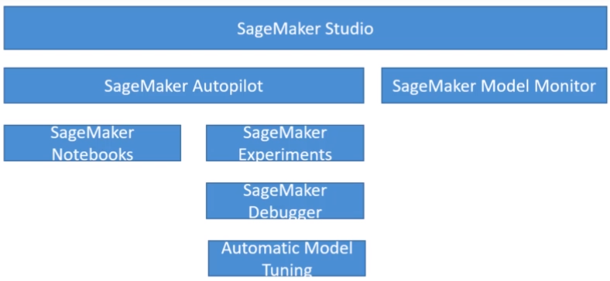

**4.26. SageMaker recent features**

* JumpStart - One-click models and algorithms from over 150 open-source models (NLP, object detections, image classification, etc).
* Data wrangler - Import, transform, analyze, or export data from SageMaker Studio.
* Feature Store - Find, discover, and share features, that are then organized in feature groups in Studio. Online (low latency) or Offline (training or batch inferences) modes are available.
* Edge manager - Software agent for edge devices where the model is optimized with SageMaker Neo. Collects and samples data from edge devices for monitoring, labeling, and retraining.

**4.27. SageMaker Canvas**

* No-code ML for Bussiness Analysts.
* Upload CSV data from S3 (for local file upload, it must be enabled by the IT admin), select the target column to be predicted, clean data (outliers, missing values, duplicates) & build the model (auto-selection), and make predictions.
* Allows dataset joins.
* Works with classification or regression algorithms.
* Allows sharing models & datasets with SageMaker Studio.
* Allows integration with Okta SSO (user sign-in).
* Manual updating in Canvas living within SageMaker domain.
* Allows import from Redshift warehouse.
* Time series can be enabled via IAM.
* Allows running within VPC.
* 1.90$/hr + charge based of no. of training cells.

**4.28. SageMaker Training Compiler**

* Optimized compiler to compile and optimize models during training (training jobs) on GPU instances.
* Integrated into AWS DL Containers (DLCs). No custom container is allowed.
* Can accelerate training up to 50%.
* Converts the models into hardware-optimized instructions.
* Tested using built-in Hugging Face Transformers library or using own model.
* Incompatible with SageMaker Distributed training libraries.
* GPU instances must be used, Pytorch model must use PyTorch/XLA’s model save function, and for debugging model enable debug flag in compiler_config parameter.

**5. Higher Level AI-ML Services**

* For general audiences than ML developers.

Refer to other notes.

**5. SageMaker Implementation and Operations**

**5.1. SageMaker + Docker**

* Models in SageMaker are hosted in Docker container as docker image in ECR that conforms to some specifications eg. location and how it's called.

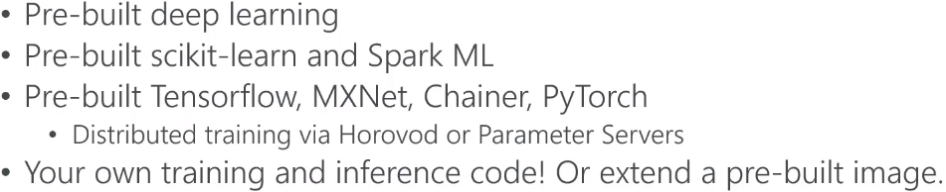

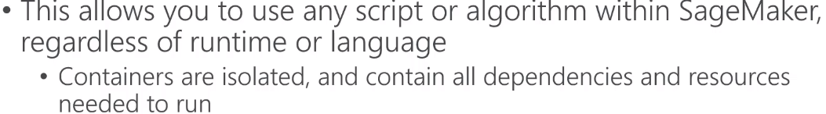

* Docker containers are created from images, images are built from dockerfile, and are saved in the repository (Elastic Container Registry).
* Structure of training container

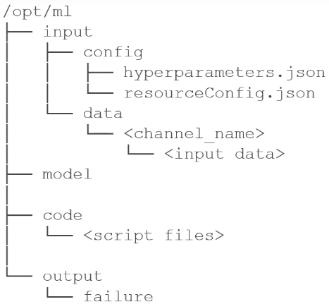

* Structure if deployment container

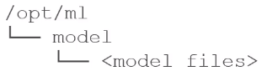

Environment variables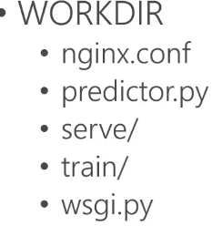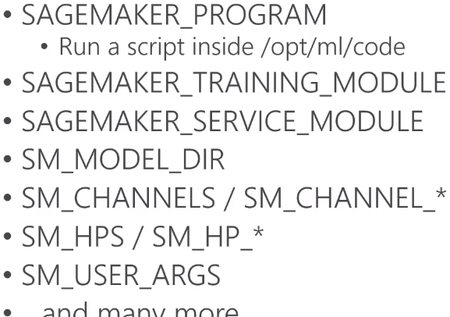

* Test multiple models on live traffic using Production variants. Variants weights are used to inform sagemaker how to distribute traffic among models.
* These variants can be effective in evaluating the new model by first initiating less % of weights to the new model and more % of weights to the existing one, gradually increasing the weights as the new model gains more confidence and at last replacing the existing one with the new model.

**5.2. SageMaker on the Edge**

* SageMaker Neo to deploy models on edge devices (eg, embedded in car computers, DeepLens, etc). Train once run anywhere. Supports architecture: ARM, Intel, NVidia processors.
* Neo optimizes code for specific devices (Tensorflow, MXNet, XGBoost, PyTorch, ONNX). It consists of a compiler and a runtime library.

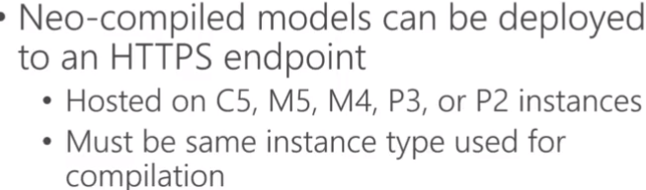

* Neo pairs well with IoT Greengrass. Model is compiled using Neo and trained model code is deployed to edge devices. Lambda functions are used for inference applications.



**5.3. SageMaker Security**

* General Security:

IAM to restrict services interacting with each other.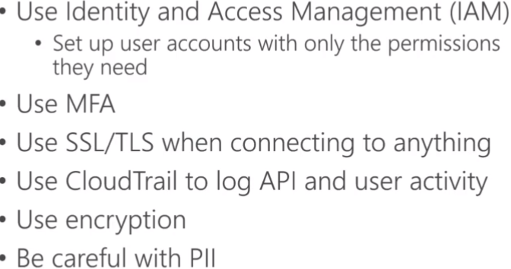

MFA (Multi-factor Authentication).

(especially with EMR clusters).

CloudTrail to audit, track, trail and log activities. CloudWatch to monitor logs and alert for issues/events (can integrate with GroundTruth).

* Protecting Data at REST in SageMaker:

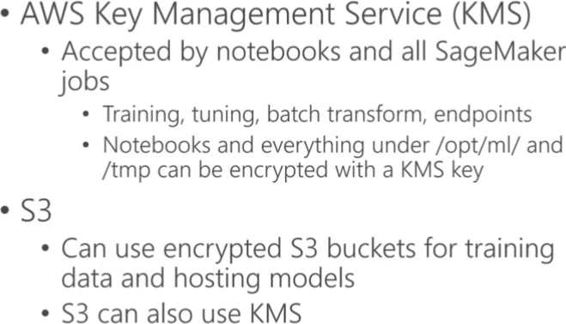

* In transit, security is done using SSL/TLS, use IAM roles assigned to SageMaker to give it permission to access resources. Inter-node training communication can be encrypted:

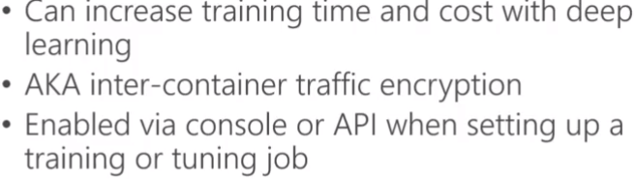

* VPC is internet enabled by default, and we can use private VPC for more security (for S3 access set up S3 VPC endpoints using custom endpoint policies or S3 bucket policies).
* If VPC internet is disabled, there can be security holes:





* IAM Permission and Policies for SageMaker:

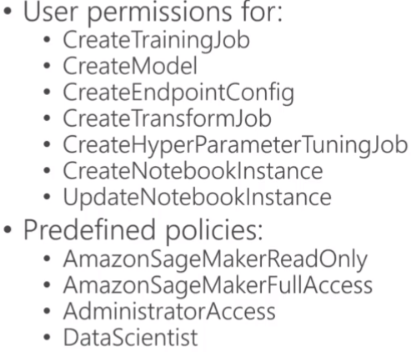

**5.4. SageMaker Resource Management**

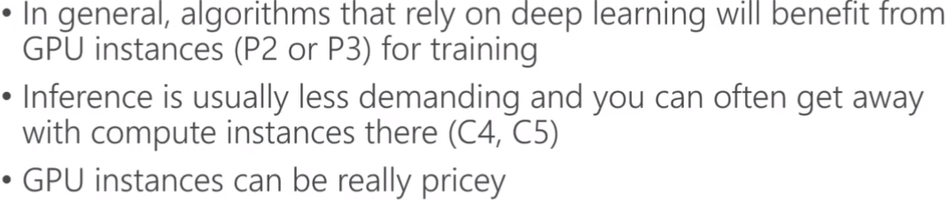

* Save 90% cost over on-demand instances using EC2 Spot instance training. Use checkpoints to S3 to overcome the problem of interruption while using Spot instances so that training can resume. Increase in training time as you need to wait for Spot instances to become available.
* Elastic Inference:

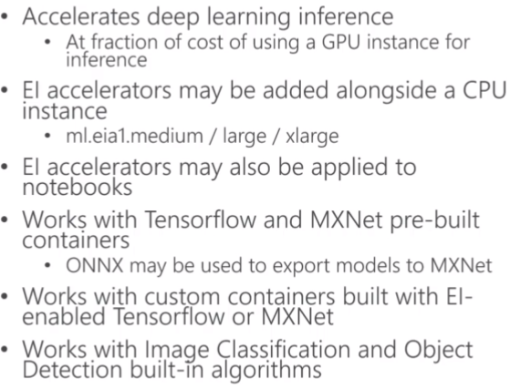

* Automatic scaling of inference nodes:

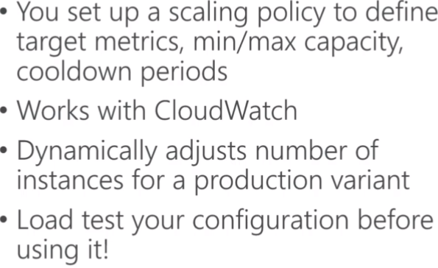

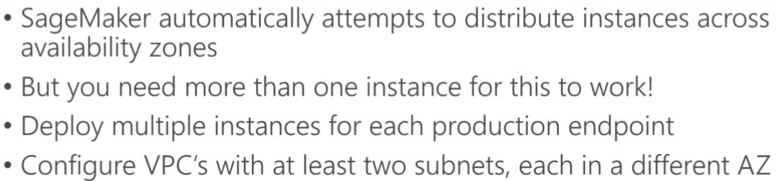

* Serverless Inference:

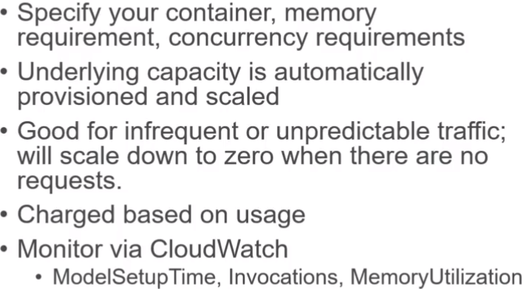

* SageMaker Inference Recommender for recommending instance types & configuration for models. Automates load testing, model tuning, and deploys to optimal inference endpoint.

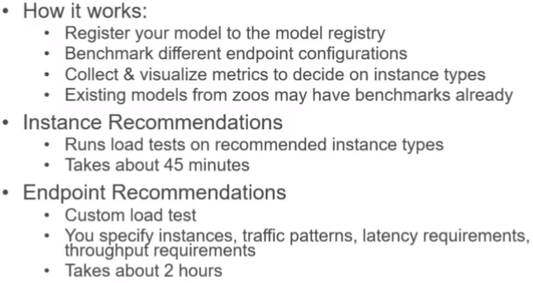

**5.4. Inference Pipelines**

Hook or tie pre-trained built-in algorithms, or own algorithms hosted on Docker containers together.

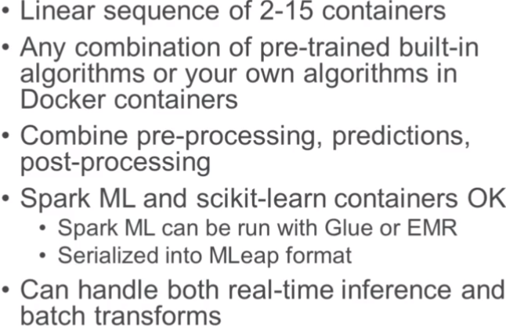

VPC - VPC = Peering, VPC - OnPrem = DirectConnect (fast dedicated), Transit Gateway for all type of connections.